GO-FISH

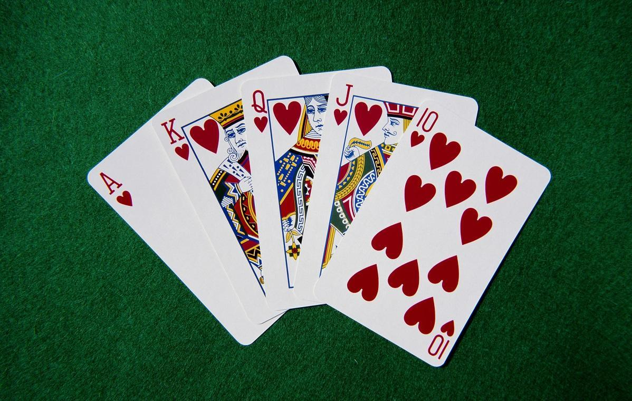

Team Members:

**Bryan Castro:**

Sequence diagrams

In-game rule display

Test cases

Use case diagrams

Class diagrams

**Justin Gustowski:**

Test cases

Ingame pause menu

Use case diagrams

**Ryan Mendoza:**

Use case diagrams

Sequence diagrams

Powerpoint Presentation

**Kevin Siraki:**

Go fish code

Implementing Assets

Implementing Schema for Detailed Use Case

Implementing AI

Project proposal

UML Class Diagrams

Table of Contents:

1. Summary of Change - 4
2. Project Proposal - 5
3. Glossary of Terms - 8
4. System Requirements - 9
5. Requirements Specifications - 11
6. Primary Class List - 13
7. Class Diagram - 14
8. Use Cases - 22
9. Use Case Diagrams - 23
10. Sequence Diagrams - 35
11. GUI Mockups - 38
12. Implementation Plan - 47
13. Implementation Breakdown - 48
14. Implementation Overview - 49
15. Test Cases – 53
16. Class Skeleton - 66
17. Source Code - 77

SUMMARY OF CHANGES

|  |  |
| --- | --- |
| **Change made to project** | **Date** |
| Removed login account | 4/1/21 |
| Removed user profile creation | 4/2/21 |
| Removed time based games and clock display | 4/3/21 |
| Removed in game currency | 4/5/21 |
| Included a user friendly UI | 4/15/21 |
| Added sound effects to cards | 4/28/21 |
| Added victory sound effect | 4/29/21 |
| No longer allow user to change background | 5/6/21 |
| Implemented a pause system that can send user to main menu | 5/10/21 |

PROJECT PROPOSAL

**Topic: Go Fish game**

After thoroughly brainstorming several ideas such as CPU hardware monitoring application or E-Commerce app/website, I decided upon making the popular card game Go-Fish with a twist in order to make the project a bit more challenging. I will work to either include an AI to play against or implement some sort of multiplayer system.

**Motivation/Interest:**

Go-Fish was always one of my favorite card games to play since I was a child. The logic of the game is quite simple and it can be played for hours without getting bored. Moreover, I have built a few games for fun on the side throughout my life in Python and Java and have also done a bit of work in Unity, so I think it would be interesting to put all of these skills together in order to design some sort of desktop application that showcases some programming experience that I already possess. However, this will also entail a large learning process for me as I have not delved into programming anything that either implements net coding, nor have I ever written a ton of code that utilizes AI. This will be an interesting project for me as I begin to delve into either network programming or gain a deeper understanding of how to implement an AI into a game.

**Problems that are being solved/investigated:**

First and foremost, I must consider what programming language(s) I wish to use for this project. There are a wide variety of options at my disposal, such as Unity2D with C#, Java, Python, or maybe something completely different such as JS. Next, as I stated previously, I will need to get a lot of research done to be able to introduce LAN based gameplay in my card game (or AI). Next, I decided upon implementing such features in order to combat the problem of the game coming out too boring or simple. Next, I must come up with which devices this game should work on. With the time allotted to us, I definitely will be able to get the game to work on Windows devices.

**Description of the deliverable:**

I plan to make a 2 player (or more) Go-Fish game that follows the standard set of rules for the game (see references). The game will either feature some sort of AI to play against or a multiplayer system (or both). WE plan to make the game in C#.

**General Rules:**

<https://howdoyouplayit.com/fish-rules-play-fish/>

**An example of someone else’s implementation (technically single player) (some sort of simple reference):**

<https://cardgames.io/gofish/>

User interface:

1. Click on card you(the turn player) are asking for(system checks for go fish)
2. Points displayed on players bottom left
3. Timer displayed on center left
4. Colorful background(fun atmosphere)
5. Settings(top right of screen)->change background color, quit, restart,
6. User profile picture(bottom right)
7. Option to play without login
8. Make login account
9. Display rules in main menu

Data management:

1. Store wins
2. Store personal background,avatar,card design
3. Store coins for in game purchases and store login information

Assets:

1. The cards themselves could be stored as .png files
2. <https://rosettacode.org/wiki/Go_Fish/C%2B%2B> (c++)
3. <https://github.com/sagardnshah/Go-Fish> (For UI)
4. music(speeds up/changes as time runs out)/victory and defeat/main menu/in game store
5. <https://youtu.be/xNjyG8S4_kI> (main menu/store music?)

Mechanics and Rules:

1. Go fish rules(<https://bicyclecards.com/how-to-play/go-fish/>)
2. Display the main menu
3. Take user login if they want to make a login
4. (player selects difficulty/difficulty increases as player wins)?
5. Special rules(ex:give losing player a boost; gets 2 turns in a row if guessed wrong 5 times in a row)
6. Time based(whoever has the most points at the end wins)
7. If the points between 2 players is the same then its a draw(tiebreaker? Both players draw top card and higher value wins)

Implementation:

* Unity
* C sharp
* Sprites of cards are PNGs

Glossary of Terms

Go-fish - the name of the game and the term used by a player when they do not possess the card the opponent asks for; the opponent then takes one card from the main deck and adds to their hand

A.I. or bot - the bot is your opponent in the game of Go-fish

cards - Go-fish uses the standard 52 pack of playing cards consisting of A, K, Q, J, 10, 9, 8, 7, 6, 5, 4, 3, 2 in groups of four (clubs, diamonds, hearts, spades)

book(s) - a player has a book of cards when the have gotten 4 of a kind; i.e. when a player has gotten all four of the ‘8’ cards from the deck they have a book

play - this asks the opponent for the card you have selected and if they don’t have it they add another card from the deck; when it’s the opponent's turn this action either gives up the card that was asked for or has you “Go fish” and take a card from the deck

start - this starts the game of “Go fish” against the opponent or bot

end - this action ends the game and takes you back to the main menu

System Requirements

Functional:

|  |  |  |
| --- | --- | --- |
| Identifier | Priority | Requirements |
| REQ-1 | 5 | Allow user to ask go fish |
| REQ-2 | 5 | AI and user draw 7 cards at start of round |
| REQ-3 | 5 | AI asks user for cards within its hand |
| REQ-4 | 5 | AI checks its hand for card to pair with the card that the user asked for |
| REQ-5 | 5 | Implementing the deck of cards |
| REQ-6 | 5 | Each player can only ask for one card per turn that is in their hand |
| REQ-7 | 5 | If the opposing player does not have a card to pair with the turn player, the turn player draws one card from the deck |
| REQ-8 | 5 | Players are awarded points for each pair acquired |
| REQ-9 | 2 | Deck shuffler |
| REQ-10 | 5 | Starting a game from the main menu |
| REQ-11 | 5 | Terminating game |
| REQ-12 | 4 | Allow user to see rules |
| REQ-13 | 3 | Allow user to pause game |
| REQ-14 | 2 | Allow user to view list of cards paired during a game |

Non-Functional

|  |  |  |  |
| --- | --- | --- | --- |
| Identifier | Type | Priority | Requirements |
| REQ-15 | Non functional | 3 | Music/sounds in main menu and in game |
| REQ-16 | Non functional | 4 | Displaying the number/card asked for in game |

Requirement Specifications

1. In the result that a player fails to make a pair during their turn, they should be able to draw a card from the deck. If that card is the same as the card the player asked for, then he may continue his turn.
2. All players have to draw an equal amount of cards to start the game
3. Allow the a.i to ask user for card to pair that is among one of the cards in its hand
4. The opponent’s hand is checked to ensure whether of not the card suit match is possible.If not the turn player is told to “go fish”
5. The game shall be played using a standard deck of 52 playing cards
6. The turn Player can only select one card within their hand at a time to pair with the opposing player's hand.If the turn player successfully makes a pair then they get another turn and may ask again for a card to pair with.
7. In the result that the turn player failed to make a pair, they must draw a card from the deck and if the card drawn is of the same suit as the one asked for; then the turn player may ask for a card again.
8. In the result that a player acquires a book of cards (pair of 4) they are given a point and the cards are set beside them. The player with the most points/books wins.
9. The deck is shuffled to ensure that the games are fair and neither player can know what cards others possess.
10. User will be allowed to start the game when they are ready from the main menu
11. User will be able to end the program whenever they no longer wish to play from the main menu of the in game pause menu
12. User will be able to view the rules and objective of the game from the main menu
13. Users will be allowed to pause the game using the esc key. The user will then be allowed to resume the game, start over ,return to the menu or terminate the program
14. Players will be able to see the cards that have been paired so that they may make better guesses on which card their opponent may have. It also shows the player how many points each player has.
15. Ingame sounds inform the player that an action has been made such as a card selection and victory music tells the player that the game has ended and a winner has been crowned
16. The selected card to be paired will be displayed at the bottom of the screen to prevent player confusion as to which card has been asked for.

Primary Class List

1. Game
2. Card
3. RTest
4. ProtectedData
5. Player
6. PauseMenu
7. Lobby
8. GameDataManager
9. Constants
10. MouseActions
11. CardAnimation
12. CardAnimator
13. (Suits/Ranks are Enums)

Class Diagrams:

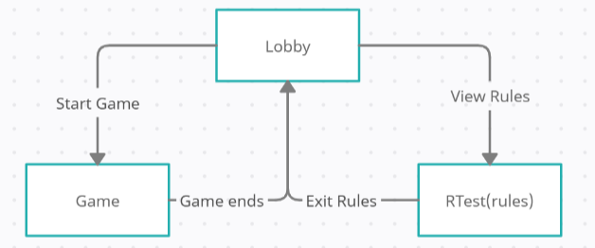

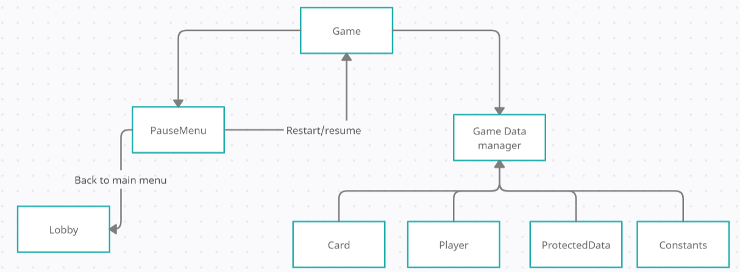

UML Class Diagrams

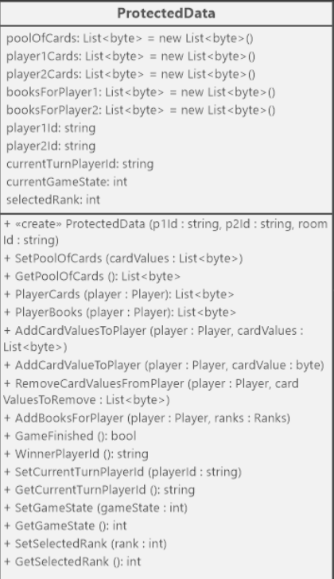

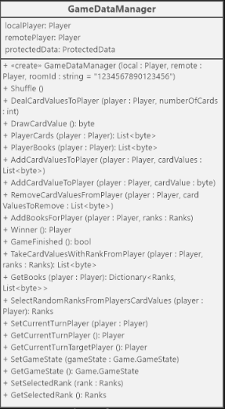

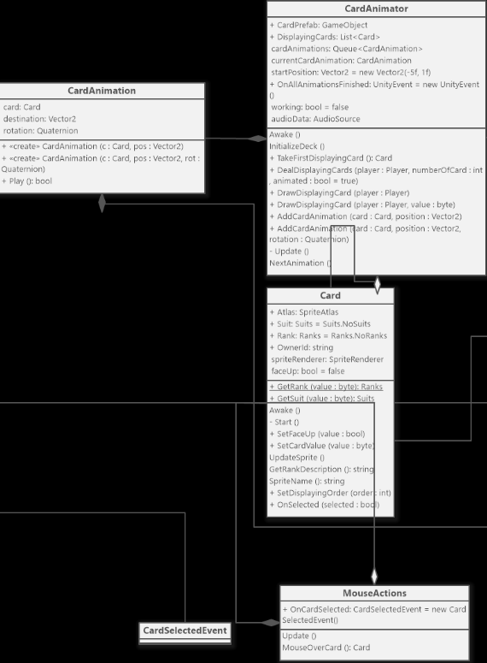

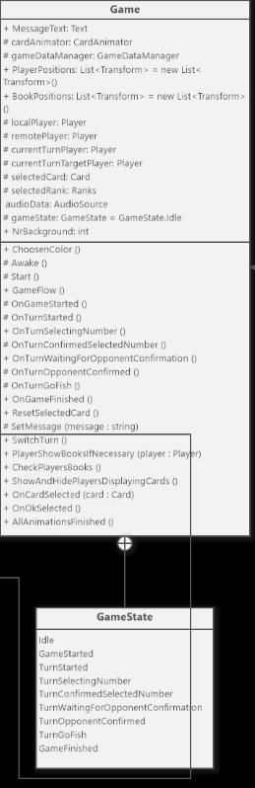

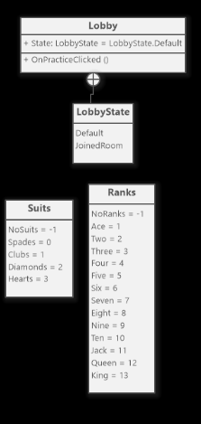

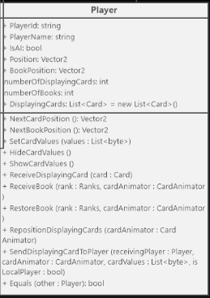

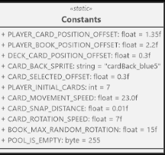

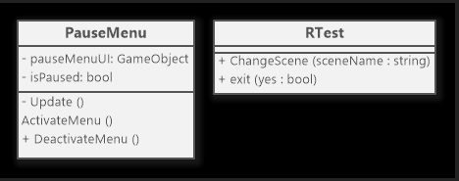

Use Cases

|  |  |  |
| --- | --- | --- |
| Actor | Actors goal | Use case name() |
| user | To ask A.I . for a card to pair within the turn player’s hand | Pair(UC-1) |
| user | To start the game | start(UC-2) |
| user | To quit the game | Exit(UC-3) |
| user | To view the rules | Guide(UC-4) |
| user | To Pause the game | Pause(UC-5) |
| user | To draw a card when no pair is made | GoFish(UC-6) |
| A.I. | To ask user for a card to pair within its hand | Pair(UC-1) |
| A.I. | To draw a card when no pair is made | GoFish(UC-6) |

Use Case Diagrams

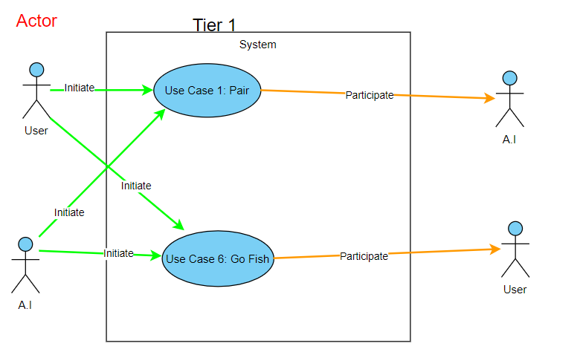

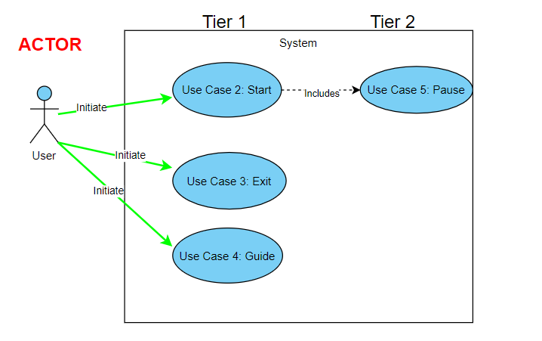

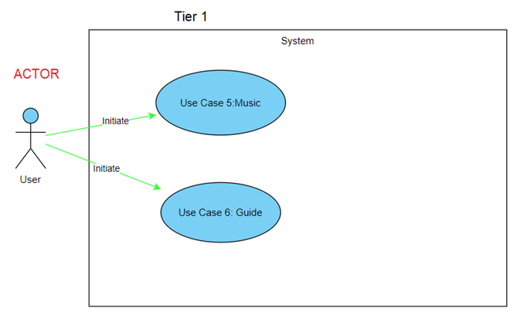

Schema for Detailed Use Case

|  |  |
| --- | --- |
| Use Case UC-1:Pair | |
| Related requirements | Req-4,Req-7 |
| Initiating actor | User |
| Actors Goal | To ask the opposing player for a card to pair that is within their hand |
| Participating actors | A.I. |
| Preconditions | The game must have started |
| Postconditions | Score updated |
| Flow of events for main success | ->Game has started  <-User acquires a hand of cards  ->User asks A.I. for a pair  <-If A.I. has pair then User gains a point  <-If A.I. doesn’t have pair then the game continues |

|  |  |
| --- | --- |
| Use Case UC-2:Start | |
| Related requirements | Req-2,Req-3,Req-6,Req-9,Req-10,  Req-11,Req-12,Req-15 |
| Initiating actor | User |
| Actors Goal | To play go fish |
| Participating actors | none |
| Preconditions | none |
| Postconditions | none |
| Flow of events for main success | ->User types launches the game on their computer  ->User clicks start game  <-GameScene is loaded |

|  |  |
| --- | --- |
| Use Case UC-3:Exit | |
| Related requirements | Req-16 |
| Initiating actor | User |
| Actors Goal | To end the game |
| Participating actors | none |
| Preconditions | none |
| Postconditions | User goes back to menu |
| Flow of events for main success | ->User has finished playing their game  ->User clicks on the exit icon  ->User leaves the game |

|  |  |
| --- | --- |
| Use Case UC-4:Rules | |
| Related requirements | Req-14,Req-17 |
| Initiating actor | User |
| Actors Goal | To display the rule scene |
| Participating actors | none |
| Preconditions | none |
| Postconditions | none |
| Flow of events for main success | ->User goes into rules scene by pressing rules button  ->User presses back button in rules scene to return to the main menu  <- Menu Scene is loaded |

|  |  |
| --- | --- |
| Use Case UC-5:Pause | |
| Related requirements | Req-13,Req-14 |
| Initiating actor | User |
| Actors Goal | To pause the gameplay and activate the pause menu |
| Participating actors | none |
| Preconditions | none |
| Postconditions | none |
| Flow of events for main success | ->User can press ESC to display pause menu  <-If user clicks on resume the game continues  <-If a user selects exit the game closes  <-If a user selects menu the game returns to the menu scene  <- If a user selects restart, the GameScene is reset and so is their progress. |

|  |  |
| --- | --- |
| Use Case UC-6:Go Fish | |
| Related requirements | Req-1,Req-5,Req-8 |
| Initiating actor | User,A.I. |
| Actors Goal | To inform opponent/A.I. that the pair can not be made so the turn player must draw a card |
| Participating actors | A.I.,User |
| Preconditions | Turn player incorrectly guesses a card in the opposing players hand |
| Postconditions | Turn player draws a card |
| Flow of events for main success | ->User has started a game  <-Both user and A.I loaded in  <-User and A.I all have their hand of cards  <-User or A.I. asks for a pair  <-User or A.I. doesn’t have a pair  <- or -> User or A.I tells the player to go fish  ->Player draws a card |

Traceability matrix

|  |  |  |  |  |  |  |  |
| --- | --- | --- | --- | --- | --- | --- | --- |
| Req’t | Pw | UC1 | UC2 | UC3 | UC4 | UC5 | UC6 |
| Req-1 | 5 |  |  |  |  |  |  |
| Req-2 | 5 |  | X |  |  |  |  |
| Req-3 | 5 |  | X |  |  |  |  |
| Req-4 | 5 | X |  |  |  |  |  |
| Req-5 | 5 |  |  |  |  |  |  |
| Req-6 | 5 |  | X |  |  |  |  |
| Req-7 | 5 | X |  |  |  |  |  |
| Req-8 | 5 |  |  |  |  |  |  |
| Req-9 | 5 |  | X |  |  |  |  |
| Req-10 | 5 |  | X |  |  |  |  |
| Req-11 | 5 |  | X |  |  |  |  |
| Req-12 | 2 |  | X |  |  |  |  |
| Req-13 | 2 |  |  |  |  | X |  |
| Req-14 | 1 |  |  |  | X | X | X |
| Req-15 | 3 |  | X |  |  |  |  |
| Req-16 | 5 |  |  | X |  |  |  |
| Req-17 | 5 |  |  |  | X |  |  |
| Req-18 | 2 |  |  |  |  |  | X |
| Req-19 | 3 |  |  |  |  |  |  |
| Req-20 | 2 |  |  |  |  |  |  |
| Max PW | | 5 | 5 | 5 | 5 | 2 | 2 |
| Total PW | | 10 | 35 | 5 | 6 | 3 | 3 |

Sequence Diagrams:

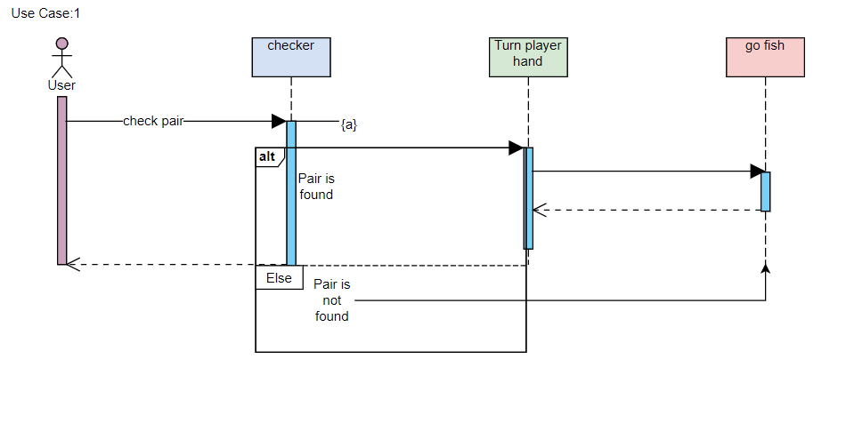

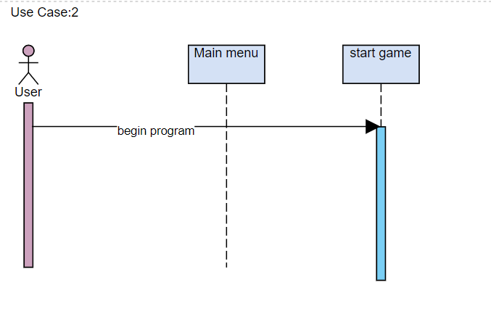

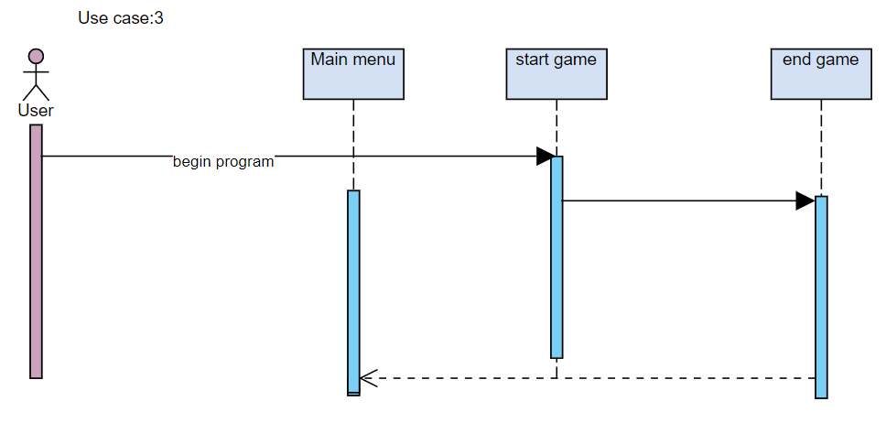

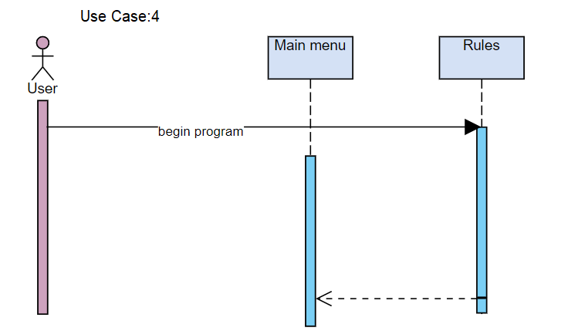

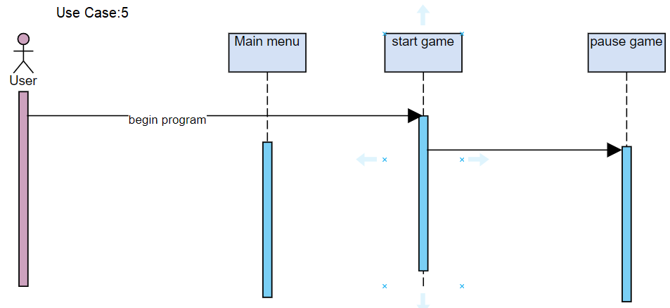

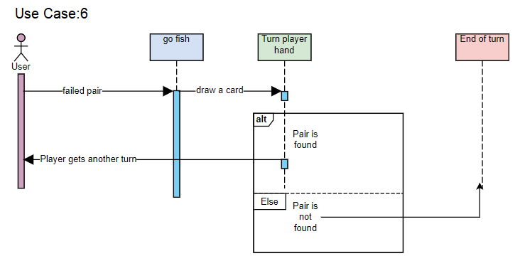

**GUI Mockups**

**Menu (No Selection):**

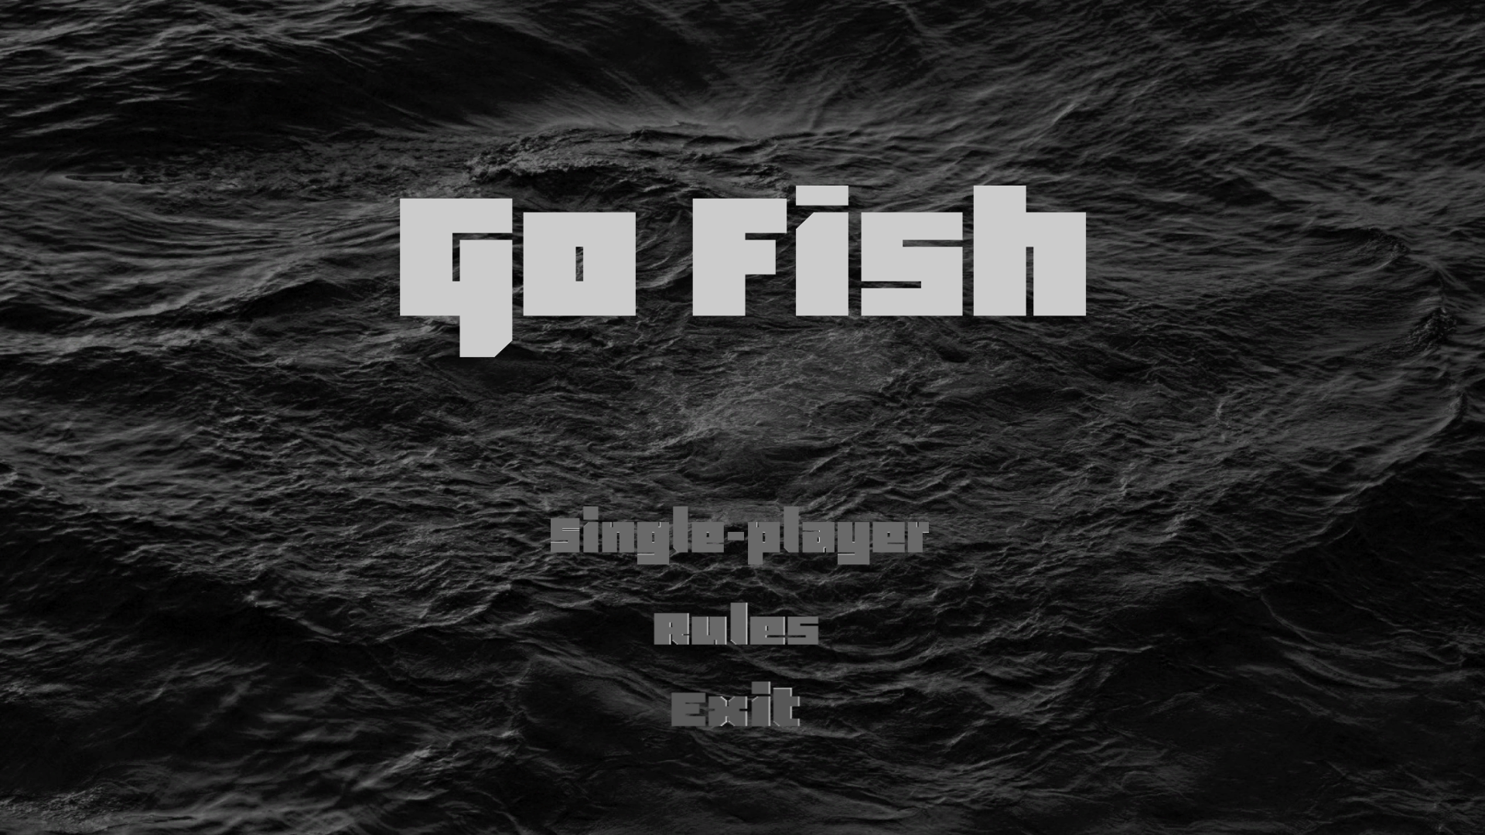

**Menu (Hover SinglePlayer)**

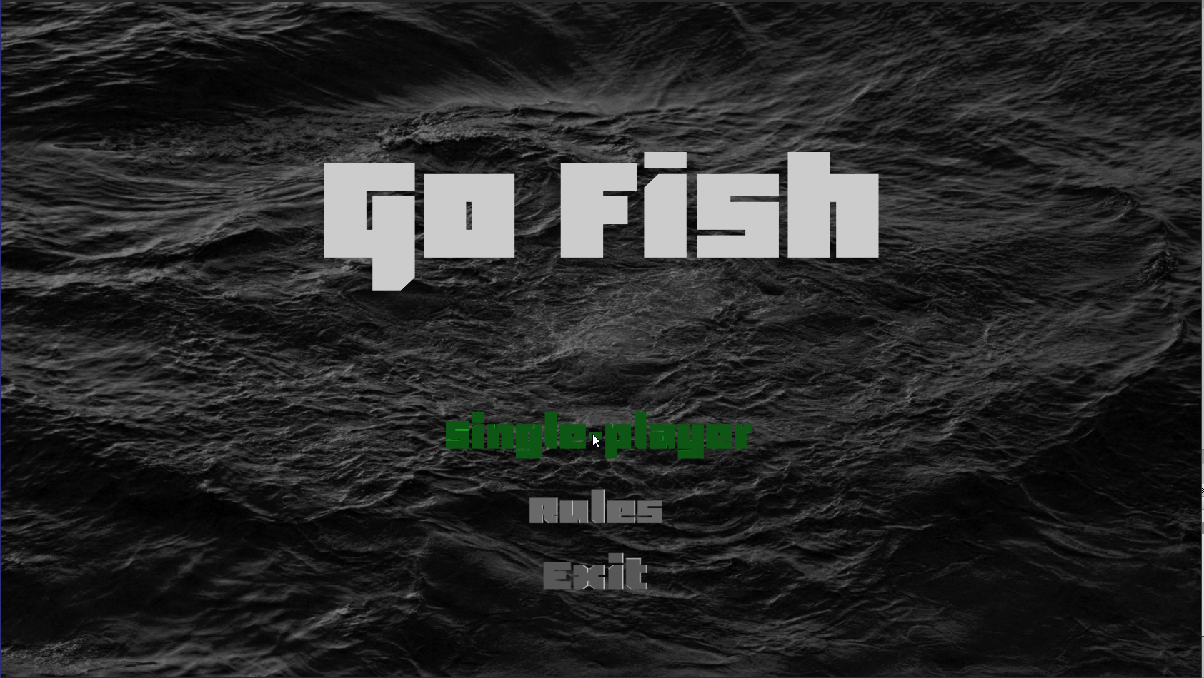

**Menu (Hover Rules):**

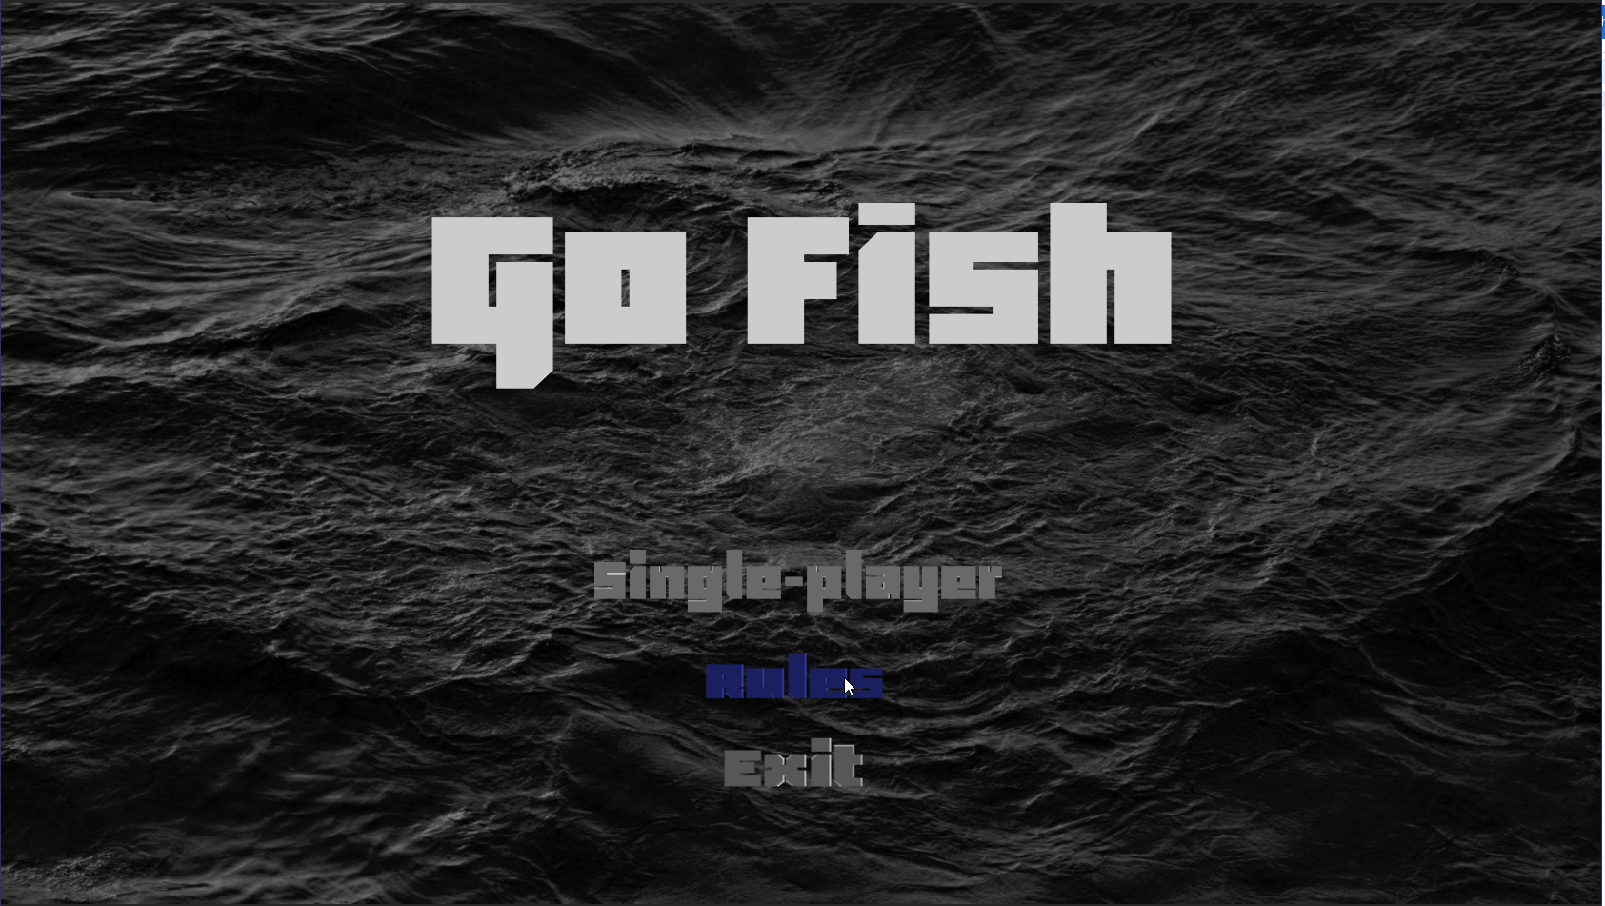

**Menu (Hover Exit):**

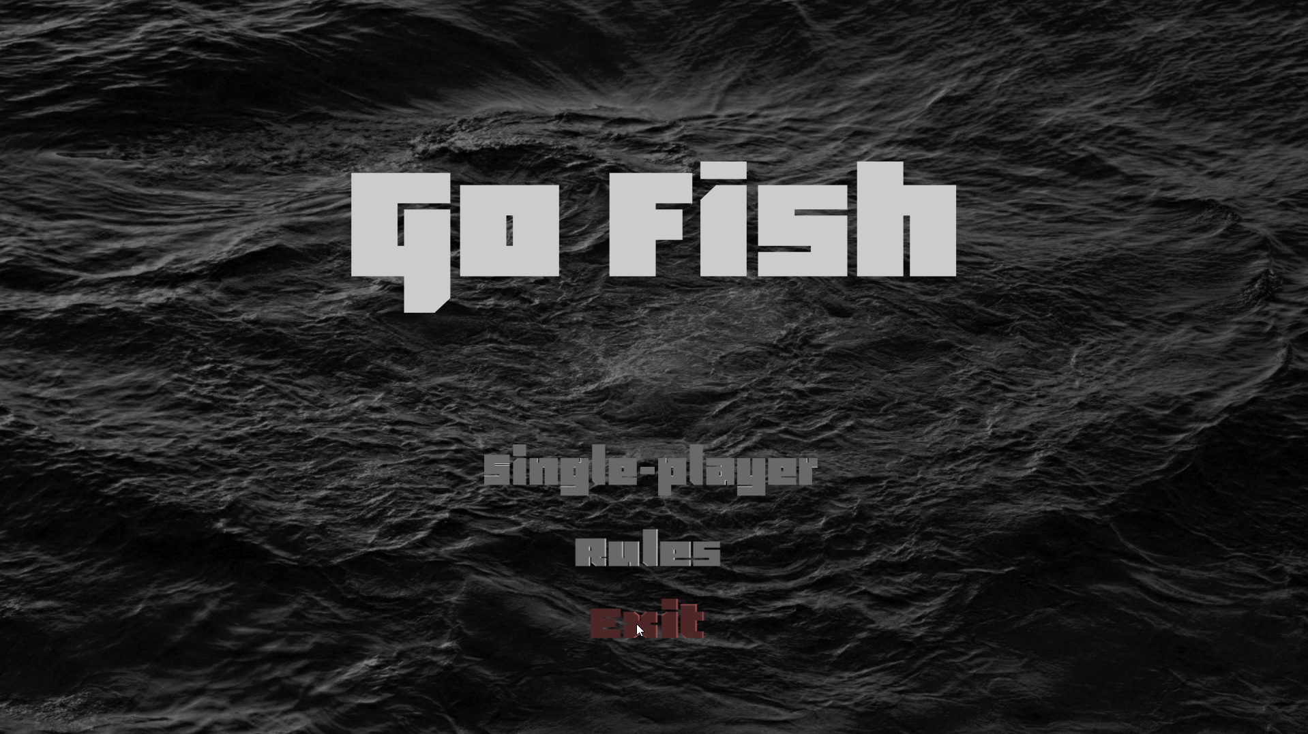

**Pause Menu [Hovering (white BG)]**

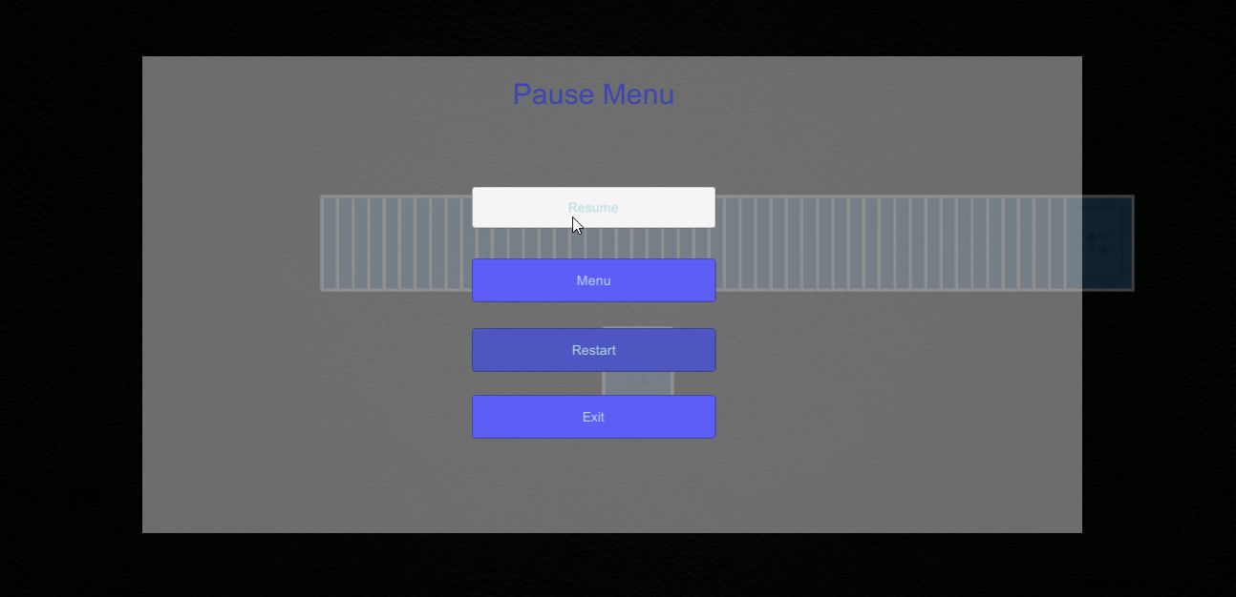

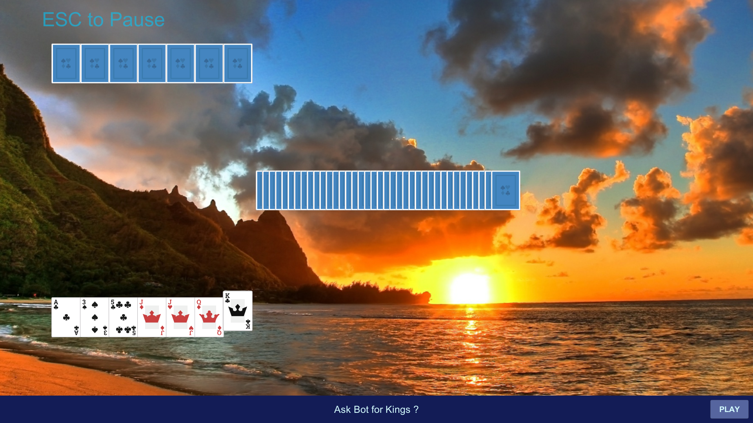

**Pause Menu (No Selection/Hover)**

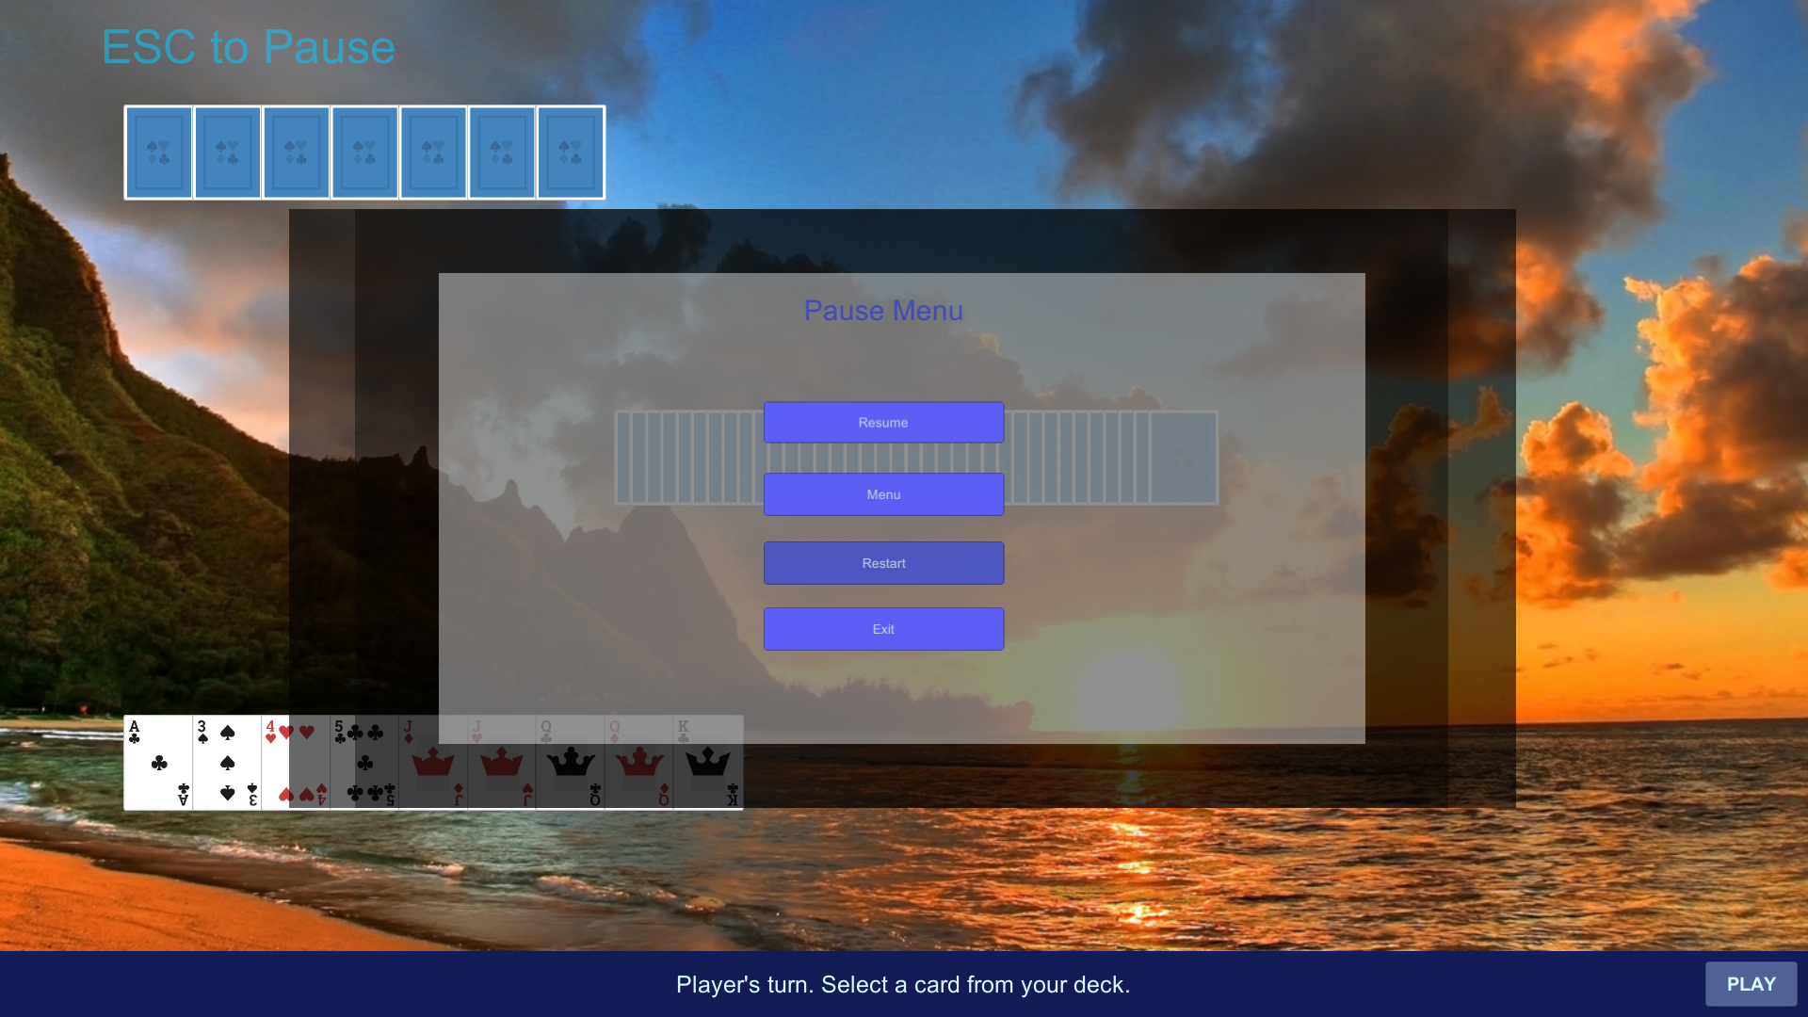

**Gameplay Sample (Stack of 4 Matching Cards):**

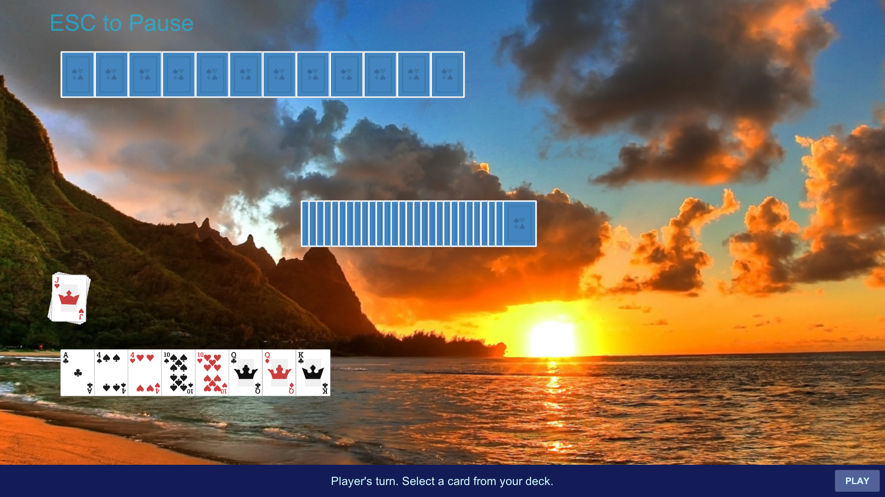

**Rules Scene:**

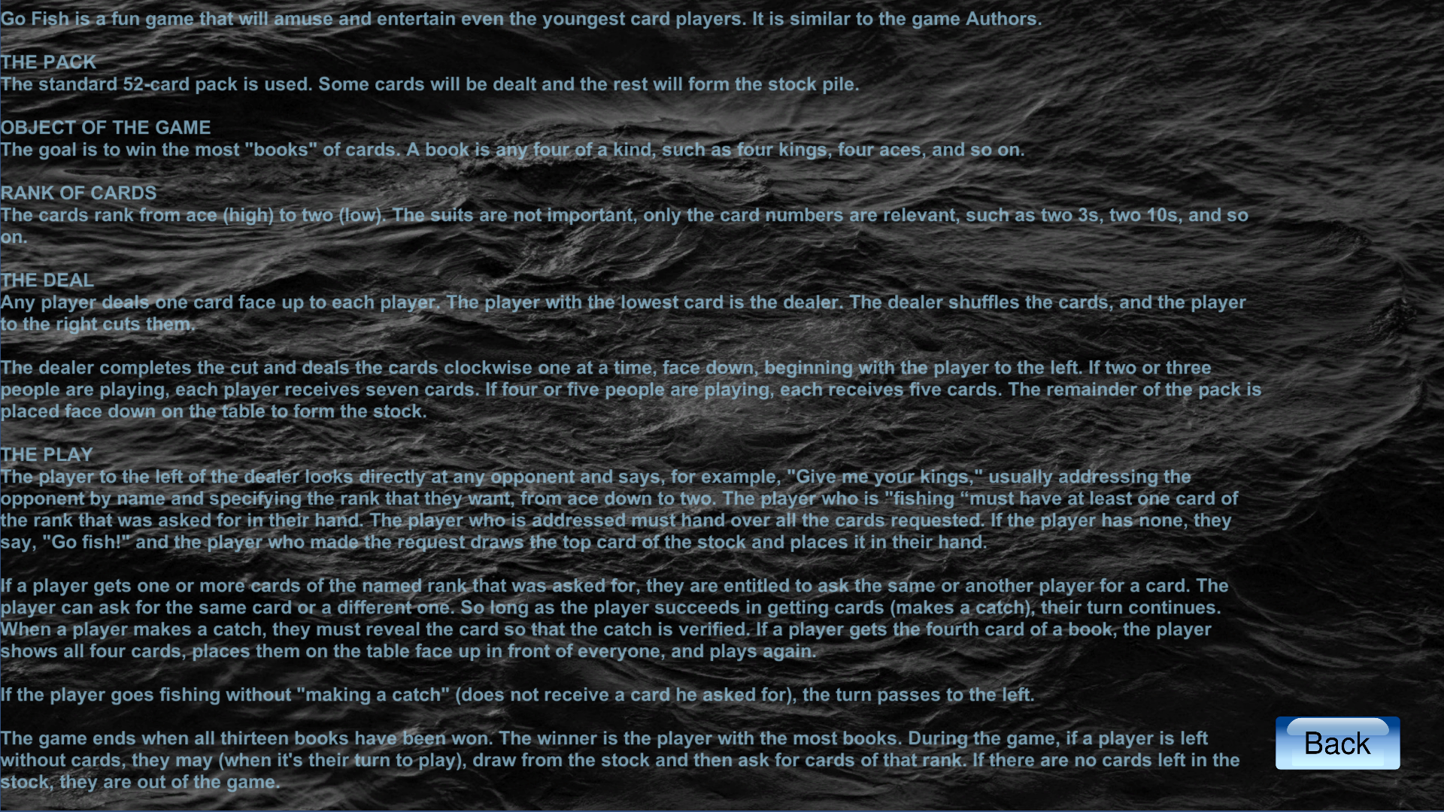

**Implementation plan**

Phase I:

* Menu class

-Start

-Settings

-Rules

-Exit

* Game class
* Rules class

Phase II:

* AI class
* Online class
* Game display ratio
* Scene change buttons

Phase III:

* Background adjustment
* Font adjustment
* In game sounds
* Reward class

**Implementation breakdown**

|  |  |  |  |  |  |  |  |  |  |
| --- | --- | --- | --- | --- | --- | --- | --- | --- | --- |
| **Week** | **7** | **8** | **9** | **10** | **11** | **12** | **13** | **14** | **15** |
| **Activity** | | | | | | | | | |
| Phase I coding |  |  |  |  |  |  |  |  |  |
| Phase I unit testing |  |  |  |  |  |  |  |  |  |
| Phase I Integration |  |  |  |  |  |  |  |  |  |
| Phase I Integration Testing |  |  |  |  |  |  |  |  |  |
| Phase I User Testing |  |  |  |  |  |  |  |  |  |
| Phase II coding |  |  |  |  |  |  |  |  |  |
| Phase II unit testing |  |  |  |  |  |  |  |  |  |
| Phase II Integration |  |  |  |  |  |  |  |  |  |
| Phase II Integration Testing |  |  |  |  |  |  |  |  |  |
| Phase II User Testing |  |  |  |  |  |  |  |  |  |
| Phase III coding |  |  |  |  |  |  |  |  |  |
| Phase III unit testing |  |  |  |  |  |  |  |  |  |
| Phase III Integration |  |  |  |  |  |  |  |  |  |
| Phase III Integration Testing |  |  |  |  |  |  |  |  |  |
| Phase III User Testing |  |  |  |  |  |  |  |  |  |

**Implementation Overview**

The implementation of our game will be approached in a “Top-Down” manner, meaning we designed the classes and modules from the top to the bottom. Our implementation will be broken down into three phases. The 1st phase will consist of the main classes that make the game software work as intended. These classes will contain the basic information and interactions required for the user to play the software (game).The majority of use cases will be covered in this phase. The 2nd phase will expand upon the 1st by enabling the user to play with the computer (AI) and others online. It will also connect the various classes to make the game whole. The 3rd phase will contain the rest of the use cases. The purpose of phase 3 will be to make the software appear more appealing to the user through visuals and sound effects. All coding will be done through visual studio for windows and done in c sharp. We will be using Unity to develop and test our game to aid in visual and program debugging.

Test Cases:

|  |  |
| --- | --- |
| Test Case Identifier: | TC-1 |
| Use Case Tested | UC-1,UC-6 |
| Pass/Fail Criteria: | The test passes if a card asked for is paired with a card from the opponent's hand if they have it in their possession. |
| Input Data | Name of card from turn players hand |
| Test procedure: | Expected result: |
| Step 1: User asks for a card in their hand when the opposing player doesn't have said card  Step 2: User asks for a card in their hand when the opposing player does have it. | User does not pair a card and is told to go fish and then it's the opposing player's turn.  User makes a pair and is allowed to ask for another card to pair |

|  |  |
| --- | --- |
| Test Case Identifier: | TC-2 |
| Use Case Tested | UC-2 |
| Pass/Fail Criteria: | The test passes if the game begins and cards are distributed to each player. |
| Input Data | User selects start on the menu(1st option) |
| Test procedure: | Expected result: |
| Step 1:User selects to start the game from menu  Step 2: user is able to interact with game | The cards are displayed to the player  User is able to ask for cards to pair |

|  |  |
| --- | --- |
| Test Case Identifier: | TC-3 |
| Use Case Tested | UC-3 |
| Pass/Fail Criteria: | The test passes if the game ends and the user is sent back to the main menu |
| Input Data | Exit option is selected |
| Test procedure: | Expected result: |
| Step 1: User selects the option to exit the game | The game ends and the user is returned to the main menu. |

|  |  |
| --- | --- |
| Test Case Identifier: | TC-4 |
| Use Case Tested | UC-4 |
| Pass/Fail Criteria: | The Test passes if the rules of the game are displayed |
| Input Data | The 3rd option in the main menu |
| Test procedure: | Expected result: |
| Step1 :user selects the rules option in the main menu | The rules of the game are displayed |

|  |  |
| --- | --- |
| Test Case Identifier: | TC-5 |
| Use Case Tested | UC-5 |
| Pass/Fail Criteria: | The test passes if the game is paused and the pause menu is shown |
| Input Data | The pause option is selected |
| Test procedure: | Expected result: |
| Step 1: The user selected the pause option | The game stands still and the pause menu is shown |

|  |  |
| --- | --- |
| Test Case Identifier: | TC-6 |
| Use Case Tested | UC-1,UC-6 |
| Pass/Fail Criteria: | The test passes if the turn player failed to make a pair and has drawn a card from the pile |
| Input Data | Name of card from turn players hand |
| Test procedure: | Expected result: |
| Step 1: User incorrectly guesses a card to pair with the opponent | User is told go fish and draws a card from the pile |

State Based Testing:

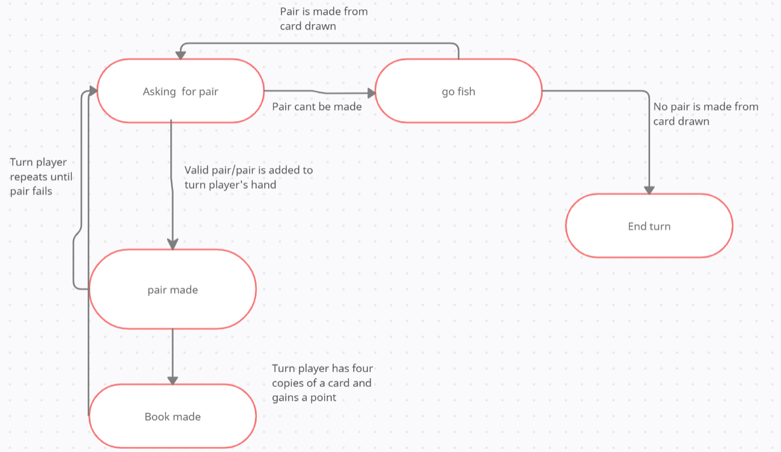

**Test Cases:**

|  |  |
| --- | --- |
| **Test Case Identifier:** | **TC-1** |
| **Use Case Tested** | **UC-1** |
| **Pass/Fail Criteria:** | **The test passes if a card asked for is paired with a card from the opponent's hand if they have it in their possession.** |
| **Input Data** | **Name of card from turn players hand** |
| **Test procedure:** | **Expected result:** |
| **Step 1: User asks for a card in their hand when the opposing player doesn't have said card**    **Step 2: User asks for a card in their hand when the opposing player does have it.** | **User does not pair a card and is told to go fish and then it's the opposing player's turn.**      **User makes a pair and is allowed to ask for another card to pair** |

|  |  |
| --- | --- |
| **Test Case Identifier:** | **TC-2** |
| **Use Case Tested** | **UC-2** |
| **Pass/Fail Criteria:** | **The test passes if the game begins and cards are distributed to each player.** |
| **Input Data** | **User selects start on the menu(1st option)** |
| **Test procedure:** | **Expected result:** |
| **Step 1:User selects to start the game from menu**    **Step 2: user is able to interact with game** | **The cards are displayed to the player**    **User is able to ask for cards to pair** |

|  |  |
| --- | --- |
| **Test Case Identifier:** | **TC-3** |
| **Use Case Tested** | **UC-3** |
| **Pass/Fail Criteria:** | **The test passes if the game ends and the user is sent back to the main menu** |
| **Input Data** | **Exit option is selected** |
| **Test procedure:** | **Expected result:** |
| **Step 1: User selects the option to exit the game** | **The game ends and the user is returned to the main menu.** |

|  |  |
| --- | --- |
| **Test Case Identifier:** | **TC-4** |
| **Use Case Tested** | **UC-4** |
| **Pass/Fail Criteria:** | **The test passes if the rules scene works** |
| **Input Data** | **User selects rules button** |
| **Test procedure:** | **Expected result:** |
| **Step 1: User selects desired color from settings** | **Rules are displayed** |

|  |  |
| --- | --- |
| **Test Case Identifier:** | **TC-5** |
| **Use Case Tested** | **UC-5** |
| **Pass/Fail Criteria:** | **The test passses if the pause functionality works** |
| **Input Data** | **Used hits ESC to pause** |
| **Test procedure:** | **Expected result:** |
| **Step 1: User selects to mute audio when its on**    **Step 2: User selects to resume audio when it is muted** | **The pause menu pops up** |

|  |  |
| --- | --- |
| **Test Case Identifier:** | **TC-6** |
| **Use Case Tested** | **UC-6** |
| **Pass/Fail Criteria:** | **The Test passes if the go fish function works** |
| **Input Data** | **Press “Play” button** |
| **Test procedure:** | **Expected result:** |
| **Step1 :user selects the rules option in the main menu** | **If AI/User do not have a card, a card is pulled from the deck** |

|  |  |
| --- | --- |
| **Test Case Identifier:** | **TC-9** |
| **Use Case Tested** | **UC-1** |
| **Pass/Fail Criteria:** | **The test passes if the turn player failed to make a pair and has drawn a card from the pile** |
| **Input Data** | **Name of card from turn players hand** |
| **Test procedure:** | **Expected result:** |
| **Step 1: User incorrectly guesses a card to pair with the opponent** | **User is told go fish and draws a card from the pile** |

**Problem Frames**

**Use Case-1 Pair:**

**- Req-4, Req-7**

**· Transformational**

|  |
| --- |
| **· Input & Output Data Structures:**  **· Array or List** |
| **· Traversal rules of Data Structures:**  **· Iterated over from a for loop** |
| **· Mapping Rules for elements of data structures:**  **· Per iteration of for loop, each elements is placed into the pair array in order**  **· Pairs are not transformed** |

**· Simple Work pieces**

|  |
| --- |
| **· Data structures:**  **· The ranks of the cards in each players hand are stored in an enum** |
| **· Requested commands:**  **· Ask for card to pair(turn player must have at least one copy of card requested)**  **· May be iterated over by a for loop** |
| **· Command applicability under different scenarios:**  **· Applicable to each turn a player takes** |
| **· Consequences of unacceptable commands:**  **· User clicks on a card to ask the AI for when it is not their turn or they must Go-Fish**  **· User clicks the Play button when they actually should select a card** |

**· Required Behavior**

|  |
| --- |
| **· Existing behavior of the controlled domain:**  **· To ask the opposing player for a card to pair that is within their hand** |
| **· Required Behavior of the controlled domain:**  **· Provide the card to the AI** |
| **· Capabilities of available “sensors”:**  **· The user will be able to select a card to ask the AI for** |

**· Information Display**

|  |
| --- |
| **· Required information to observe:**  **· Number of cards in players deck** |
| **· Required information to visualize:**  **· Display the cards to on the front-end to the user** |
| **· Rules for visualization of the observed information:**  **· The cards will be PNG sprites that will be displayed at a speed controlled by Constants.cs** |

**· Commanded Behavior**

|  |
| --- |
| **· Requested user commands:**  **· Click on Card, Accept Go-Fish Play** |
| **· Commands applicability under different scenarios:**  **· The AI is asking for a card**  **· The user asks the AI for a card**  **· The user or AI have to go-fish** |
| **· Consequences of unacceptable commands:**  **· When the user tries to select a card to request from the AI when it is not their turn, the card will remain static. They can only press the Play button.** |

**· Use Case-3 Exit: (REQ-16)**

**· Transformational**

|  |
| --- |
| **· Input and output data structures:**  **· Windows API (most likely singly linked list)** |
| **· Traversal rules of Data Structures:**  **· For-Each loop** |
| **· Mapping Rules for elements of data structures:**  **· Handled by the Windows API, most likely a threaded while loop awaiting user input.** |

**· Simple Work pieces**

|  |
| --- |
| **· Data structures:**  **· FormClosed Event** |
| **· Requested commands:**  **· User to navigate mouse to exit button**  **· User to click it** |
| **· Command applicability under different scenarios:**  **· Applicable to a user, or two users if multiplayer is implemented** |
| **· Consequences of unacceptable commands:**  **· User may select the wrong Windows forms button such as minimize.** |

**· Information Display**

|  |
| --- |
| **· Required information to observe:**  **· Is the user currently in a game?** |
| **· Required information to visualize:**  **· The button itself must be presented to the user** |
| **· Rules for visualization of the observed information:**  **· Windows API must be included in the project.** |

**· Required Behavior**

|  |
| --- |
| **· Existing behavior of the controlled domain:**  **· To end the game** |
| **· Required behavior of the controlled domain:**  **· There must be a mouse input from the user themselves on the exit icon in order for them to exit the application** |
| **· Capabilities of available “sensors”:**  **· User has finished playing their game**  **· User clicks on the exit icon**  **· User leaves the game** |

**· Commanded Behavior**

|  |
| --- |
| **· Requested user commands:**  **· Press the exit button**  **· Ending the game** |
| **· Commands applicability under different scenarios:**  **· The user will lose their game progress if they exit the game**  **· User must be in an active game in order to exit** |
| **· Consequences of unacceptable commands:**  **· The user may accidentally minimize the game if they miss-click** |

~Class Skeleton~

Card:

namespace GoFish {}

public static Suits GetSuit(byte value) {}

public SpriteAtlas Atlas;

public Suits Suit = Suits.NoSuits;

public Ranks Rank = Ranks.NoRanks;

public string OwnerId;

SpriteRenderer spriteRenderer;

bool faceUp = false;

void Awake() {}

private void Start() {}

public void SetFaceUp(bool value) {}

public void SetCardValue(byte value) {}

void UpdateSprite() {}

string GetRankDescription() {}

string SpriteName() {} {}

return testName;

public void SetDisplayingOrder(int order) {}

public void OnSelected(bool selected) {}

CardAnimator:

namespace GoFish {}

public CardAnimation(Card c, Vector2 pos, Quaternion rot) {}

public bool Play() {}

else {}

return finished;

public class CardAnimator: MonoBehaviour {}

void InitializeDeck() {}

public Card TakeFirstDisplayingCard() {}

public void DealDisplayingCards(Player player, int numberOfCard, bool animated = true) {}

public void DrawDisplayingCard(Player player) {}

public void DrawDisplayingCard(Player player, byte value) {}

public void AddCardAnimation(Card card, Vector2 position) {}

public void AddCardAnimation(Card card, Vector2 position, Quaternion rotation) {}

private void Update() {}

void NextAnimation() {}

Constants:

namespace GoFish {}

public enum Suits {}

public enum Ranks {}

Game:

namespace GoFish {};

[SerializeField]

protected GameState gameState = GameState.Idle;

public int NrBackground;

public void ChoosenColor() {}

protected void Awake() {}

protected void Start() {}

//****************** Game Flow *********************//

public virtual void GameFlow() {}

switch (gameState) {}

case GameState.GameStarted: {}

case GameState.TurnStarted: {}

case GameState.TurnSelectingNumber: {}

case GameState.TurnConfirmedSelectedNumber: {}

case GameState.TurnWaitingForOpponentConfirmation: {}

case GameState.TurnOpponentConfirmed: {}

case GameState.TurnGoFish: {}

case GameState.GameFinished: {}

protected virtual void OnGameStarted() {}

protected virtual void OnTurnStarted() {}

public void OnTurnSelectingNumber() {}

protected virtual void OnTurnConfirmedSelectedNumber() {}

public void OnTurnWaitingForOpponentConfirmation() {}

protected virtual void OnTurnOpponentConfirmed() {}

protected virtual void OnTurnGoFish() {}

public void OnGameFinished() {}

//****************** Helper Methods *********************//

public void ResetSelectedCard() {}

protected void SetMessage(string message) {}

public void SwitchTurn() {}

if (currentTurnPlayer == localPlayer) {} else {}

public void PlayerShowBooksIfNecessary(Player player) {}

public void CheckPlayersBooks() {}

public void ShowAndHidePlayersDisplayingCards() {}

//****************** User Interaction *********************//

public void OnCardSelected(Card card) {}

public virtual void OnOkSelected() {}

GameDataManager:

namespace GoFish {}

public void Shuffle() {}

public void DealCardValuesToPlayer(Player player, int numberOfCards) {}

public byte DrawCardValue() {}

public List < byte > PlayerCards(Player player) {}

public List < byte > PlayerBooks(Player player) {}

public void AddCardValuesToPlayer(Player player, List < byte > cardValues) {}

public void AddCardValueToPlayer(Player player, byte cardValue) {}

public void RemoveCardValuesFromPlayer(Player player, List < byte > cardValuesToRemove) {}

public void AddBooksForPlayer(Player player, Ranks ranks) {}

public Player Winner() {}

public bool GameFinished() {}

public List < byte > TakeCardValuesWithRankFromPlayer(Player player, Ranks ranks) {}

public Dictionary < Ranks, List < byte >> GetBooks(Player player) {}

public Ranks SelectRandomRanksFromPlayersCardValues(Player player) {}

public void SetCurrentTurnPlayer(Player player) {}

public Player GetCurrentTurnPlayer() {}

public Player GetCurrentTurnTargetPlayer() {}

public void SetGameState(Game.GameState gameState) {}

public Game.GameState GetGameState() {}

public void SetSelectedRank(Ranks rank) {}

public Ranks GetSelectedRank() {}

Lobby:

namespace GoFish {}

public LobbyState State = LobbyState.Default; //for SP

public void OnPracticeClicked() {}

MouseActions:

namespace GoFish {}

public class MouseActions: MonoBehaviour {}

Card MouseOverCard() {}

PauseMenu:

public class PauseMenu: MonoBehaviour {}

void ActivateMenu() {}

public void DeactivateMenu() {}

Player:

namespace GoFish {}

public Vector2 NextBookPosition() {}

public void SetCardValues(List < byte > values) {}

public void HideCardValues() {}

public void ShowCardValues() {}

public void ReceiveDisplayingCard(Card card) {}

public void ReceiveBook(Ranks rank, CardAnimator cardAnimator) {}

public void RestoreBook(Ranks rank, CardAnimator cardAnimator) {}

public void RepositionDisplayingCards(CardAnimator cardAnimator) {}

public void SendDisplayingCardToPlayer(Player receivingPlayer, CardAnimator cardAnimator, List < byte > cardValues, bool isLocalPlayer) {}

public bool Equals(Player other) {}

ProtectedData:

namespace GoFish {}

public void SetPoolOfCards(List < byte > cardValues) {}

public List < byte > GetPoolOfCards() {}

public List < byte > PlayerCards(Player player) {}

public List < byte > PlayerBooks(Player player) {}

public void AddCardValuesToPlayer(Player player, List < byte > cardValues) {}

public void AddCardValueToPlayer(Player player, byte cardValue) {}

public void RemoveCardValuesFromPlayer(Player player, List < byte > cardValuesToRemove) {}

public void AddBooksForPlayer(Player player, Ranks ranks) {}

public bool GameFinished() {}

public string WinnerPlayerId() {}

public void SetCurrentTurnPlayerId(string playerId) {}

public string GetCurrentTurnPlayerId() {}

public void SetGameState(int gameState) {}

public int GetGameState() {}

public void SetSelectedRank(int rank) {}

public int GetSelectedRank() {}

RTest:

public class RTest: MonoBehaviour {}

public void ChangeScene(string sceneName){}

public void exit(bool yes) {}

~Source Code~

Card:

using System.ComponentModel;

using System.Reflection;

using UnityEngine;

using UnityEngine.U2D;

namespace GoFish {

    public class Card : MonoBehaviour { /// SetFaceUp(false) clears card's face value

        public static Ranks GetRank(byte value) { // To display a card's value, call SetCardValue(byte) to assign the Rank and the Suit to the card, then call SetFaceUp(true)

            return (Ranks)(value / 4 + 1);

        }

        public static Suits GetSuit(byte value) {

            return (Suits)(value % 4);

        }

        public SpriteAtlas Atlas;

        public Suits Suit = Suits.NoSuits;

        public Ranks Rank = Ranks.NoRanks;

        public string OwnerId;

        SpriteRenderer spriteRenderer;

        bool faceUp = false;

        void Awake() {

            spriteRenderer = GetComponent<SpriteRenderer>();

        }

        private void Start() {

            UpdateSprite();

        }

        public void SetFaceUp(bool value) {

            faceUp = value;

            UpdateSprite();

            if (value == false) { // Setting faceup to false also resets card's value.

                Rank = Ranks.NoRanks;

                Suit = Suits.NoSuits;

            }

        }

        public void SetCardValue(byte value) { // 0-3 are 1's // 4-7 are 2's // ... // 48-51 are kings's

            Rank = (Ranks)(value / 4 + 1);

            Suit = (Suits)(value % 4);  // 0, 4, 8, 12, 16, 20, 24, 28, 32, 36, 40, 44, 48 are Spades(0)

        }

        void UpdateSprite() {

            if (faceUp) spriteRenderer.sprite = Atlas.GetSprite(SpriteName());

            else spriteRenderer.sprite = Atlas.GetSprite(Constants.CARD_BACK_SPRITE);

        }

        string GetRankDescription() {

            FieldInfo fieldInfo = Rank.GetType().GetField(Rank.ToString());

            DescriptionAttribute[] attributes = fieldInfo.GetCustomAttributes(typeof(DescriptionAttribute), false) as DescriptionAttribute[];

            return attributes[0].Description;

        }

        string SpriteName() {

            string testName = $"card{Suit}{GetRankDescription()}";

            return testName;

        }

        public void SetDisplayingOrder(int order) {

            spriteRenderer.sortingOrder = order;

        }

        public void OnSelected(bool selected) {

            if (selected) transform.position = (Vector2)transform.position + Vector2.up * Constants.CARD_SELECTED_OFFSET;

            else transform.position = (Vector2)transform.position - Vector2.up * Constants.CARD_SELECTED_OFFSET;

        }

    }

}

CardAnimator:

using System.Collections;

using System.Collections.Generic;

using UnityEngine;

using UnityEngine.Events;

using System.Collections;

using System.Collections.Generic;

using UnityEngine;

using UnityEngine.SceneManagement;

namespace GoFish {

    public class CardAnimation   {

        Card card;

        Vector2 destination;

        Quaternion rotation;

        public CardAnimation(Card c, Vector2 pos) {

            card = c;

            destination = pos;

            rotation = Quaternion.identity;

        }

        public CardAnimation(Card c, Vector2 pos, Quaternion rot) {

            card = c;

            destination = pos;

            rotation = rot;

        }

        public bool Play() {

            bool finished = false;

            if (Vector2.Distance(card.transform.position, destination) < Constants.CARD_SNAP_DISTANCE) {

                card.transform.position = destination;

                finished = true;

            }

            else {

                card.transform.position = Vector2.MoveTowards(card.transform.position, destination, Constants.CARD_MOVEMENT_SPEED * Time.deltaTime);

                card.transform.rotation = Quaternion.Lerp(card.transform.rotation, rotation, Constants.CARD_ROTATION_SPEED * Time.deltaTime);

            }

            return finished;

        }

    }

    public class CardAnimator : MonoBehaviour { //card animations

        public GameObject CardPrefab;

        public List<Card> DisplayingCards;

        Queue<CardAnimation> cardAnimations;

        CardAnimation currentCardAnimation;

        Vector2 startPosition = new Vector2(-5f, 1f);

        public UnityEvent OnAllAnimationsFinished = new UnityEvent(); // invoked when all queued card animations have been played

        bool working = false;

        AudioSource audioData;

        void Awake() {

            audioData = GetComponent<AudioSource>();

            cardAnimations = new Queue<CardAnimation>();

            InitializeDeck();

        }

        void InitializeDeck() {

            DisplayingCards = new List<Card>();

            for (byte value = 0; value < 52; value++) {

                Vector2 newPosition = startPosition + Vector2.right * Constants.DECK_CARD_POSITION_OFFSET * value;

                GameObject newGameObject = Instantiate(CardPrefab, newPosition, Quaternion.identity);

                newGameObject.transform.parent = transform;

                Card card = newGameObject.GetComponent<Card>();

                card.SetDisplayingOrder(-1);

                card.transform.position = newPosition;

                DisplayingCards.Add(card);

            }

        }

        public Card TakeFirstDisplayingCard() {

            int numberOfDisplayingCard = DisplayingCards.Count;

            if (numberOfDisplayingCard > 0) {

                Card card = DisplayingCards[numberOfDisplayingCard - 1];

                DisplayingCards.Remove(card);

                return card;

            }

            return null;

        }

        public void DealDisplayingCards(Player player, int numberOfCard, bool animated = true) {

            int start = DisplayingCards.Count - 1;

            int finish = DisplayingCards.Count - 1 - numberOfCard;

            List<Card> cardsToRemoveFromDeck = new List<Card>();

            for (int i = start; i > finish; i--) {

                Card card = DisplayingCards[i];

                player.ReceiveDisplayingCard(card);

                cardsToRemoveFromDeck.Add(card);

                if (animated) AddCardAnimation(card, player.NextCardPosition());

                else card.transform.position = player.NextCardPosition();

            }

            foreach (Card card in cardsToRemoveFromDeck) DisplayingCards.Remove(card);

        }

        public void DrawDisplayingCard(Player player) {

            int numberOfDisplayingCard = DisplayingCards.Count;

            if (numberOfDisplayingCard > 0) {

                Card card = DisplayingCards[numberOfDisplayingCard - 1];

                player.ReceiveDisplayingCard(card);

                AddCardAnimation(card, player.NextCardPosition());

                DisplayingCards.Remove(card);

            }

        }

        public void DrawDisplayingCard(Player player, byte value) {

            int numberOfDisplayingCard = DisplayingCards.Count;

            if (numberOfDisplayingCard > 0) {

                Card card = DisplayingCards[numberOfDisplayingCard - 1];

                card.SetCardValue(value);

                card.SetFaceUp(true);

                player.ReceiveDisplayingCard(card);

                AddCardAnimation(card, player.NextCardPosition());

                DisplayingCards.Remove(card);

            }

        }

        public void AddCardAnimation(Card card, Vector2 position) {

            CardAnimation ca = new CardAnimation(card, position);

            cardAnimations.Enqueue(ca);

            working = true;

        }

        public void AddCardAnimation(Card card, Vector2 position, Quaternion rotation) {

            CardAnimation ca = new CardAnimation(card, position, rotation);

            cardAnimations.Enqueue(ca);

            working = true;

        }

        private void Update() {

            if (Input.GetKeyDown(KeyCode.M))

            {

                SceneManager.LoadScene("LobbyScene");

                Debug.Log("menu");

            }

            if (currentCardAnimation == null) {

                NextAnimation();

            }

            else if (currentCardAnimation.Play())

            {

                NextAnimation();

                audioData.Play();

            }

        }

        void NextAnimation() {

            currentCardAnimation = null;

            if (cardAnimations.Count > 0) {

                CardAnimation ca = cardAnimations.Dequeue();

                currentCardAnimation = ca;

            }

            else if (working) {

                working = false;

                OnAllAnimationsFinished.Invoke();

            }

        }

    }

}

Constants:

using System.ComponentModel;

using UnityEngine;

namespace GoFish {

    public static class Constants {

        public const float  PLAYER_CARD_POSITION_OFFSET = 1.35f; //1.2f

        public const float  PLAYER_BOOK_POSITION_OFFSET = 2.2f; //2.0f

        public const float  DECK_CARD_POSITION_OFFSET = 0.3f; //0.2f

        public const string CARD_BACK_SPRITE = "cardBack_blue5"; //set the sprite for the back of the cards

        public const float  CARD_SELECTED_OFFSET = 0.3f;

        public const int    PLAYER_INITIAL_CARDS = 7;

        public const float  CARD_MOVEMENT_SPEED = 23.0f; //25.0f

        public const float  CARD_SNAP_DISTANCE = 0.01f;

        public const float  CARD_ROTATION_SPEED = 7f; //8f

        public const float  BOOK_MAX_RANDOM_ROTATION = 15f;

        public const byte   POOL_IS_EMPTY = 255;

    }

    public enum Suits {

        NoSuits = -1,

        Spades = 0,

        Clubs = 1,

        Diamonds = 2,

        Hearts = 3,

    }

    public enum Ranks {

        [Description("No Ranks")]

        NoRanks = -1,

        [Description("A")]

        Ace = 1,

        [Description("2")]

        Two = 2,

        [Description("3")]

        Three = 3,

        [Description("4")]

        Four = 4,

        [Description("5")]

        Five = 5,

        [Description("6")]

        Six = 6,

        [Description("7")]

        Seven = 7,

        [Description("8")]

        Eight = 8,

        [Description("9")]

        Nine = 9,

        [Description("10")]

        Ten = 10,

        [Description("J")]

        Jack = 11,

        [Description("Q")]

        Queen = 12,

        [Description("K")]

        King = 13,

    }

}

Game:

using System.Collections;

using System.Collections.Generic;

using System.Linq;

using UnityEngine;

using Unity;

using UnityEngine.UI;

namespace GoFish {

    public class Game : MonoBehaviour {

        public Text MessageText;

        protected CardAnimator cardAnimator;

        [SerializeField]

        protected GameDataManager gameDataManager;

        public List<Transform> PlayerPositions = new List<Transform>();

        public List<Transform> BookPositions = new List<Transform>();

        [SerializeField]

        protected Player localPlayer;

        [SerializeField]

        protected Player remotePlayer;

        [SerializeField]

        protected Player currentTurnPlayer;

        [SerializeField]

        protected Player currentTurnTargetPlayer;

        [SerializeField]

        protected Card selectedCard;

        [SerializeField]

        protected Ranks selectedRank;

        AudioSource audioData;

        public enum GameState {

            Idle,

            GameStarted,

            TurnStarted,

            TurnSelectingNumber,

            TurnConfirmedSelectedNumber,

            TurnWaitingForOpponentConfirmation,

            TurnOpponentConfirmed,

            TurnGoFish,

            GameFinished

        };

        [SerializeField]

        protected GameState gameState = GameState.Idle;

        public int NrBackground;

        public void ChoosenColor ()

        {

            PlayerPrefs.SetInt("ColorOfTheBackground", NrBackground);

        }

        protected void Awake() {

            audioData = GetComponent<AudioSource>();

            Debug.Log("base awake");

            localPlayer = new Player();

            localPlayer.PlayerId = "offline-player";

            localPlayer.PlayerName = "Player";

            localPlayer.Position = PlayerPositions[0].position;

            localPlayer.BookPosition = BookPositions[0].position;

            remotePlayer = new Player();

            remotePlayer.PlayerId = "offline-bot";

            remotePlayer.PlayerName = "Bot";

            remotePlayer.Position = PlayerPositions[1].position;

            remotePlayer.BookPosition = BookPositions[1].position;

            remotePlayer.IsAI = true;

            cardAnimator = FindObjectOfType<CardAnimator>();

        }

        protected void Start() {

            gameState = GameState.GameStarted;

            GameFlow();

        }

        //****************** Game Flow *********************//

        public virtual void GameFlow() {//update gamestate

            if (gameState > GameState.GameStarted) {

                CheckPlayersBooks();

                ShowAndHidePlayersDisplayingCards();

                if (gameDataManager.GameFinished()) gameState = GameState.GameFinished;

            }

            switch (gameState) {

                case GameState.Idle:

                    {

                        Debug.Log("IDLE");

                        break;

                    }

                case GameState.GameStarted:

                    {

                        Debug.Log("GameStarted");

                        OnGameStarted();

                        break;

                    }

                case GameState.TurnStarted:

                    {

                        Debug.Log("TurnStarted");

                        OnTurnStarted();

                        break;

                    }

                case GameState.TurnSelectingNumber:

                    {

                        Debug.Log("TurnSelectingNumber");

                        OnTurnSelectingNumber();

                        break;

                    }

                case GameState.TurnConfirmedSelectedNumber:

                    {

                        Debug.Log("TurnComfirmedSelectedNumber");

                        OnTurnConfirmedSelectedNumber();

                        break;

                    }

                case GameState.TurnWaitingForOpponentConfirmation:

                    {

                        Debug.Log("TurnWaitingForOpponentConfirmation");

                        OnTurnWaitingForOpponentConfirmation();

                        break;

                    }

                case GameState.TurnOpponentConfirmed:

                    {

                        Debug.Log("TurnOpponentConfirmed");

                        OnTurnOpponentConfirmed();

                        break;

                    }

                case GameState.TurnGoFish:

                    {

                        Debug.Log("TurnGoFish");

                        OnTurnGoFish();

                        break;

                    }

                case GameState.GameFinished:

                    {

                        Debug.Log("GameFinished");

                        OnGameFinished();

                        break;

                    }

            }

        }

        protected virtual void OnGameStarted() {

            gameDataManager = new GameDataManager(localPlayer, remotePlayer);

            gameDataManager.Shuffle();

            gameDataManager.DealCardValuesToPlayer(localPlayer, Constants.PLAYER_INITIAL_CARDS);

            gameDataManager.DealCardValuesToPlayer(remotePlayer, Constants.PLAYER_INITIAL_CARDS);

            cardAnimator.DealDisplayingCards(localPlayer, Constants.PLAYER_INITIAL_CARDS);

            cardAnimator.DealDisplayingCards(remotePlayer, Constants.PLAYER_INITIAL_CARDS);

            gameState = GameState.TurnStarted;

        }

        protected virtual void OnTurnStarted() {

            SwitchTurn();

            gameState = GameState.TurnSelectingNumber;

            GameFlow();

        }

        public void OnTurnSelectingNumber() {

            ResetSelectedCard();

            if (currentTurnPlayer == localPlayer) SetMessage($"Player's turn. Select a card from your deck.");

            else SetMessage($"{currentTurnPlayer.PlayerName}'s turn");

            if (currentTurnPlayer.IsAI) {

                selectedRank = gameDataManager.SelectRandomRanksFromPlayersCardValues(currentTurnPlayer);

                gameState = GameState.TurnConfirmedSelectedNumber;

                GameFlow();

            }

        }

        protected virtual void OnTurnConfirmedSelectedNumber() {

            if (currentTurnPlayer == localPlayer) SetMessage($"Asking {currentTurnTargetPlayer.PlayerName} for {selectedRank}s...");

            else SetMessage($"{currentTurnPlayer.PlayerName} is asking for {selectedRank}s...");

            gameState = GameState.TurnWaitingForOpponentConfirmation;

            GameFlow();

        }

        public void OnTurnWaitingForOpponentConfirmation() {

            if (currentTurnTargetPlayer.IsAI) {

                gameState = GameState.TurnOpponentConfirmed;

                GameFlow();

            }

        }

        protected virtual void OnTurnOpponentConfirmed()

        {

            List<byte> cardValuesFromTargetPlayer = gameDataManager.TakeCardValuesWithRankFromPlayer(currentTurnTargetPlayer, selectedRank);

            if (cardValuesFromTargetPlayer.Count > 0) {

                gameDataManager.AddCardValuesToPlayer(currentTurnPlayer, cardValuesFromTargetPlayer);

                bool senderIsLocalPlayer = currentTurnTargetPlayer == localPlayer;

                currentTurnTargetPlayer.SendDisplayingCardToPlayer(currentTurnPlayer, cardAnimator, cardValuesFromTargetPlayer, senderIsLocalPlayer);

                gameState = GameState.TurnSelectingNumber;

            }

            else {

                gameState = GameState.TurnGoFish;

                GameFlow();

            }

        }

        protected virtual void OnTurnGoFish() {

            SetMessage($"Go fish!");

            byte cardValue = gameDataManager.DrawCardValue();

            if (cardValue == Constants.POOL_IS_EMPTY) {

                Debug.LogError("Pool is empty");

                return;

            }

            if (Card.GetRank(cardValue) == selectedRank) cardAnimator.DrawDisplayingCard(currentTurnPlayer, cardValue);

            else {

                cardAnimator.DrawDisplayingCard(currentTurnPlayer);

                gameState = GameState.TurnStarted;

            }

            gameDataManager.AddCardValueToPlayer(currentTurnPlayer, cardValue);

        }

        public void OnGameFinished() {

            if (gameDataManager.Winner() == localPlayer) {

                SetMessage($"Player Wins! Press 'M' for menu.");

                audioData.Play();

            }

            else {

                SetMessage($"AI Wins! Press 'M' for menu.");

                audioData.Play();

            }

        }

        //****************** Helper Methods *********************//

        public void ResetSelectedCard() {

            if (selectedCard != null) {

                selectedCard.OnSelected(false);

                selectedCard = null;

                selectedRank = 0;

            }

        }

        protected void SetMessage(string message)

        {

            MessageText.text = message;

        }

        public void SwitchTurn() {

            if (currentTurnPlayer == null) {

                currentTurnPlayer = localPlayer;

                currentTurnTargetPlayer = remotePlayer;

                return;

            }

            if (currentTurnPlayer == localPlayer) {

                currentTurnPlayer = remotePlayer;

                currentTurnTargetPlayer = localPlayer;

            }

            else {

                currentTurnPlayer = localPlayer;

                currentTurnTargetPlayer = remotePlayer;

            }

        }

        public void PlayerShowBooksIfNecessary(Player player) {

            Dictionary<Ranks, List<byte>> books = gameDataManager.GetBooks(player);

            if (books != null) {

                foreach (var book in books) {

                    player.ReceiveBook(book.Key, cardAnimator);

                    gameDataManager.RemoveCardValuesFromPlayer(player, book.Value);

                    gameDataManager.AddBooksForPlayer(player, book.Key);

                }

            }

        }

        public void CheckPlayersBooks() {

            List<byte> playerCardValues = gameDataManager.PlayerCards(localPlayer);

            localPlayer.SetCardValues(playerCardValues);

            PlayerShowBooksIfNecessary(localPlayer);

            playerCardValues = gameDataManager.PlayerCards(remotePlayer);

            remotePlayer.SetCardValues(playerCardValues);

            PlayerShowBooksIfNecessary(remotePlayer);

        }

        public void ShowAndHidePlayersDisplayingCards() {

            localPlayer.ShowCardValues();

            remotePlayer.HideCardValues();

        }

        //****************** User Interaction *********************//

        public void OnCardSelected(Card card) {

            if (gameState == GameState.TurnSelectingNumber) {

                if (card.OwnerId == currentTurnPlayer.PlayerId) {

                    if (selectedCard != null) {

                        selectedCard.OnSelected(false);

                        selectedRank = 0;

                    }

                    selectedCard = card;

                    selectedRank = selectedCard.Rank;

                    selectedCard.OnSelected(true);

                    SetMessage($"Ask {currentTurnTargetPlayer.PlayerName} for {selectedCard.Rank}s ?");

                }

            }

        }

        public virtual void OnOkSelected() {

            if (gameState == GameState.TurnSelectingNumber && localPlayer == currentTurnPlayer) {

                if (selectedCard != null) {

                    gameState = GameState.TurnConfirmedSelectedNumber;

                    GameFlow();

                }

            }

            else if (gameState == GameState.TurnWaitingForOpponentConfirmation && localPlayer == currentTurnTargetPlayer) {

                gameState = GameState.TurnOpponentConfirmed;

                GameFlow();

            }

        }

        public virtual void AllAnimationsFinished() {

            GameFlow();

        }

    }

}

GameDataManager:

using System;

using System.Collections.Generic;

using System.Linq;

using UnityEngine;

namespace GoFish {

    [Serializable]

    public class GameDataManager {

        Player localPlayer;

        Player remotePlayer;

        [SerializeField]

        ProtectedData protectedData;

        public GameDataManager(Player local, Player remote, string roomId = "1234567890123456") { //dummy ID

            localPlayer = local;

            remotePlayer = remote;

            protectedData = new ProtectedData(localPlayer.PlayerId, remotePlayer.PlayerId, roomId);

        }

        public void Shuffle() {

            List<byte> cardValues = new List<byte>();

            for (byte value = 0; value < 52; value++) cardValues.Add(value);

            List<byte> poolOfCards = new List<byte>();

            for (int index = 0; index < 52; index++) {

                int valueIndexToAdd = UnityEngine.Random.Range(0, cardValues.Count);

                byte valueToAdd = cardValues[valueIndexToAdd];

                poolOfCards.Add(valueToAdd);

                cardValues.Remove(valueToAdd);

            }

            protectedData.SetPoolOfCards(poolOfCards);

        }

        public void DealCardValuesToPlayer(Player player, int numberOfCards) {

            List<byte> poolOfCards = protectedData.GetPoolOfCards();

            int numberOfCardsInThePool = poolOfCards.Count;

            int start = numberOfCardsInThePool - 1 - numberOfCards;

            List<byte> cardValues = poolOfCards.GetRange(start, numberOfCards);

            poolOfCards.RemoveRange(start, numberOfCards);

            protectedData.AddCardValuesToPlayer(player, cardValues);

            protectedData.SetPoolOfCards(poolOfCards);

        }

        public byte DrawCardValue() {

            List<byte> poolOfCards = protectedData.GetPoolOfCards();

            int numberOfCardsInThePool = poolOfCards.Count;

            if (numberOfCardsInThePool > 0) {

                byte cardValue = poolOfCards[numberOfCardsInThePool - 1];

                poolOfCards.Remove(cardValue);

                protectedData.SetPoolOfCards(poolOfCards);

                return cardValue;

            }

            return Constants.POOL_IS_EMPTY;

        }

        public List<byte> PlayerCards(Player player) {

            return protectedData.PlayerCards(player);

        }

        public List<byte> PlayerBooks(Player player) {

            return protectedData.PlayerBooks(player);

        }

        public void AddCardValuesToPlayer(Player player, List<byte> cardValues) {

            protectedData.AddCardValuesToPlayer(player, cardValues);

        }

        public void AddCardValueToPlayer(Player player, byte cardValue) {

            protectedData.AddCardValueToPlayer(player, cardValue);

        }

        public void RemoveCardValuesFromPlayer(Player player, List<byte> cardValuesToRemove) {

            protectedData.RemoveCardValuesFromPlayer(player, cardValuesToRemove);

        }

        public void AddBooksForPlayer(Player player, Ranks ranks) {

            protectedData.AddBooksForPlayer(player, ranks);

        }

        public Player Winner() {

            string winnerPlayerId = protectedData.WinnerPlayerId();

            if (winnerPlayerId.Equals(localPlayer.PlayerId)) return localPlayer;

            else return remotePlayer;

        }

        public bool GameFinished() {

            return protectedData.GameFinished();

        }

        public List<byte> TakeCardValuesWithRankFromPlayer(Player player, Ranks ranks) {

            List<byte> playerCards = protectedData.PlayerCards(player);

            List<byte> result = new List<byte>();

            foreach (byte cv in playerCards) if (Card.GetRank(cv) == ranks) result.Add(cv);

            protectedData.RemoveCardValuesFromPlayer(player, result);

            return result;

        }

        public Dictionary<Ranks, List<byte>> GetBooks(Player player) {

            List<byte> playerCards = protectedData.PlayerCards(player);

            var groups = playerCards.GroupBy(Card.GetRank).Where(g => g.Count() == 4);

            if (groups.Count() > 0) {

                Dictionary<Ranks, List<byte>> setOfFourDictionary = new Dictionary<Ranks, List<byte>>();

                foreach (var group in groups) {

                    List<byte> cardValues = new List<byte>();

                    foreach (var value in group) cardValues.Add(value);

                    setOfFourDictionary[group.Key] = cardValues;

                }

                return setOfFourDictionary;

            }

            return null;

        }

        public Ranks SelectRandomRanksFromPlayersCardValues(Player player) {

            List<byte> playerCards = protectedData.PlayerCards(player);

            int index = UnityEngine.Random.Range(0, playerCards.Count);

            return Card.GetRank(playerCards[index]);

        }

        public void SetCurrentTurnPlayer(Player player) {

            protectedData.SetCurrentTurnPlayerId(player.PlayerId);

        }

        public Player GetCurrentTurnPlayer() {

            string playerId = protectedData.GetCurrentTurnPlayerId();

            if (localPlayer.PlayerId.Equals(playerId)) return localPlayer;

            else return remotePlayer;

        }

        public Player GetCurrentTurnTargetPlayer() {

            string playerId = protectedData.GetCurrentTurnPlayerId();

            if (localPlayer.PlayerId.Equals(playerId)) return remotePlayer;

            else return localPlayer;

        }

        public void SetGameState(Game.GameState gameState) {

            protectedData.SetGameState((int)gameState);

        }

        public Game.GameState GetGameState() {

            return (Game.GameState)protectedData.GetGameState();

        }

        public void SetSelectedRank(Ranks rank) {

            protectedData.SetSelectedRank((int)rank);

        }

        public Ranks GetSelectedRank() {

            return (Ranks)protectedData.GetSelectedRank();

        }

    }

}

Lobby:

using System.Collections;

using System.Collections.Generic;

using UnityEngine;

using UnityEngine.UI;

using UnityEngine.SceneManagement;

namespace GoFish {

    public class Lobby : MonoBehaviour {

        public enum LobbyState {

            Default,

            JoinedRoom,

        }

        public LobbyState State = LobbyState.Default; //for SP

        public void OnPracticeClicked() { /// Practice button was clicked.

            Debug.Log("OnPracticeClicked");

            SceneManager.LoadScene("GameScene");

        }

    }

}

MouseActions:

using System;

using System.Collections;

using System.Collections.Generic;

using UnityEngine;

using UnityEngine.Events;

namespace GoFish {

    [Serializable]

    public class CardSelectedEvent : UnityEvent<Card>{}

    public class MouseActions : MonoBehaviour {

        public CardSelectedEvent OnCardSelected = new CardSelectedEvent();

        void Update() {

            if (Input.GetMouseButtonUp(0)) {

                Card card = MouseOverCard();

                if (card != null) OnCardSelected.Invoke(card);

            }

        }

        Card MouseOverCard() {

            RaycastHit2D hit = Physics2D.Raycast(Camera.main.ScreenToWorldPoint(Input.mousePosition), Vector2.zero);

            if (hit) {

                Card card = hit.transform.gameObject.GetComponent<Card>();

                if (card != null) return card;

            }

            return null;

        }

    }

}

PauseMenu:

using System;

using System.Collections;

using System.Collections.Generic;

using UnityEngine;

public class PauseMenu : MonoBehaviour

{

    [SerializeField] private GameObject pauseMenuUI;

    [SerializeField] private bool isPaused;

    private void Update()

    {

        if (Input.GetKeyDown(KeyCode.Escape))

        {

            isPaused = !isPaused;

        }

        if (isPaused)

        {

            ActivateMenu();

        }

        else

        {

            DeactivateMenu();

        }

    }

    void ActivateMenu()

    {

        Time.timeScale = 0;

        AudioListener.pause = true;

        pauseMenuUI.SetActive(true);

    }

    public void DeactivateMenu()

    {

        Time.timeScale = 1;

        AudioListener.pause = false;

        pauseMenuUI.SetActive(false);

        isPaused = false;

    }

}

Player:

using System;

using System.Collections.Generic;

using UnityEngine;

namespace GoFish { /// Manages the positions of the player's cards

    [Serializable]

    public class Player : IEquatable<Player> {

        public string PlayerId;

        public string PlayerName;

        public bool IsAI;

        public Vector2 Position;

        public Vector2 BookPosition;

        int numberOfDisplayingCards;

        int numberOfBooks;

        public List<Card> DisplayingCards = new List<Card>();

        public Vector2 NextCardPosition() {

            Vector2 nextPos = Position + Vector2.right * Constants.PLAYER_CARD_POSITION_OFFSET * numberOfDisplayingCards;

            return nextPos;

        }

        public Vector2 NextBookPosition() {

            Vector2 nextPos = BookPosition + Vector2.right * Constants.PLAYER_BOOK_POSITION_OFFSET * numberOfBooks;

            return nextPos;

        }

        public void SetCardValues(List<byte> values) {

            if (DisplayingCards.Count != values.Count) {

                Debug.LogError($"Displaying cards count {DisplayingCards.Count} is not equal to card values count {values.Count} for {PlayerId}");

                return;

            }

            for (int index = 0; index < values.Count; index++) {

                Card card = DisplayingCards[index];

                card.SetCardValue(values[index]);

                card.SetDisplayingOrder(index);

            }

        }

        public void HideCardValues() {

            foreach (Card card in DisplayingCards) card.SetFaceUp(false);

        }

        public void ShowCardValues() {

            foreach (Card card in DisplayingCards) card.SetFaceUp(true);

        }

        public void ReceiveDisplayingCard(Card card) {

            DisplayingCards.Add(card);

            card.OwnerId = PlayerId;

            numberOfDisplayingCards++;

        }

        public void ReceiveBook(Ranks rank, CardAnimator cardAnimator) {

            Vector2 targetPosition = NextBookPosition();

            List<Card> displayingCardsToRemove = new List<Card>();

            foreach (Card card in DisplayingCards) {

                if (card.Rank == rank) {

                    card.SetFaceUp(true);

                    float randomRotation = UnityEngine.Random.Range(-1 * Constants.BOOK_MAX_RANDOM_ROTATION, Constants.BOOK_MAX_RANDOM_ROTATION);

                    cardAnimator.AddCardAnimation(card, targetPosition, Quaternion.Euler(Vector3.forward * randomRotation));

                    displayingCardsToRemove.Add(card);

                }

            }

            DisplayingCards.RemoveAll(card => displayingCardsToRemove.Contains(card));

            RepositionDisplayingCards(cardAnimator);

            numberOfBooks++;

        }

        public void RestoreBook(Ranks rank, CardAnimator cardAnimator) {

            Vector2 targetPosition = NextBookPosition();

            for (int i = 0; i < 4; i++) {

                Card card = cardAnimator.TakeFirstDisplayingCard();

                int intRankValue = (int)rank;

                int cardValue = (intRankValue - 1) * 4 + i;

                card.SetCardValue((byte)cardValue);

                card.SetFaceUp(true);

                float randomRotation = UnityEngine.Random.Range(-1 * Constants.BOOK_MAX_RANDOM_ROTATION, Constants.BOOK_MAX_RANDOM_ROTATION);

                card.transform.position = targetPosition;

                card.transform.rotation = Quaternion.Euler(Vector3.forward * randomRotation);

            }

            numberOfBooks++;

        }

        public void RepositionDisplayingCards(CardAnimator cardAnimator) {

            numberOfDisplayingCards = 0;

            foreach (Card card in DisplayingCards) {

                numberOfDisplayingCards++;

                cardAnimator.AddCardAnimation(card, NextCardPosition());

            }

        }

        public void SendDisplayingCardToPlayer(Player receivingPlayer, CardAnimator cardAnimator, List<byte> cardValues, bool isLocalPlayer) {

            int playerDisplayingCardsCount = DisplayingCards.Count;

            if (playerDisplayingCardsCount < cardValues.Count) {

                Debug.LogError("Not enough displaying cards");

                return;

            }

            for (int index = 0; index < cardValues.Count; index++) {

                Card card = null;

                byte cardValue = cardValues[index];

                if (isLocalPlayer) {

                    foreach (Card c in DisplayingCards) {

                        if (c.Rank == Card.GetRank(cardValue) && c.Suit == Card.GetSuit(cardValue)) {

                            card = c;

                            break;

                        }

                    }

                }

                else {

                    card = DisplayingCards[playerDisplayingCardsCount - 1 - index];

                    card.SetCardValue(cardValue);

                    card.SetFaceUp(true);

                }

                if(card != null) {

                    DisplayingCards.Remove(card);

                    receivingPlayer.ReceiveDisplayingCard(card);

                    cardAnimator.AddCardAnimation(card, receivingPlayer.NextCardPosition());

                    numberOfDisplayingCards--;

                }

                else Debug.LogError("Unable to find displaying card.");

            }

            RepositionDisplayingCards(cardAnimator);

        }

        public bool Equals(Player other) {

            if (PlayerId.Equals(other.PlayerId)) return true;

            else return false;

        }

    }

}

ProtectedData:

using System;

using System.Collections.Generic;

using System.Linq;

using System.Text;

using UnityEngine;

namespace GoFish {

    [Serializable]

    public class ProtectedData { // Stores the important data of the game.

        [SerializeField]

        List<byte> poolOfCards = new List<byte>();

        [SerializeField]

        List<byte> player1Cards = new List<byte>();

        [SerializeField]

        List<byte> player2Cards = new List<byte>();

        [SerializeField]

        List<byte> booksForPlayer1 = new List<byte>();

        [SerializeField]

        List<byte> booksForPlayer2 = new List<byte>();

        [SerializeField]

        string player1Id;

        [SerializeField]

        string player2Id;

        [SerializeField]

        string currentTurnPlayerId;

        [SerializeField]

        int currentGameState;

        [SerializeField]

        int selectedRank;

        public ProtectedData(string p1Id, string p2Id, string roomId) {

            player1Id = p1Id;

            player2Id = p2Id;

            currentTurnPlayerId = "";

            selectedRank = (int)Ranks.NoRanks;

        }

        public void SetPoolOfCards(List<byte> cardValues) {

            poolOfCards = cardValues;

        }

        public List<byte> GetPoolOfCards() {

            List<byte> result;

            result = poolOfCards;

            return result;

        }

        public List<byte> PlayerCards(Player player) {

            List<byte> result;

            if (player.PlayerId.Equals(player1Id)) result = player1Cards;

            else result = player2Cards;

            return result;

        }

        public List<byte> PlayerBooks(Player player) {

            List<byte> result;

            if (player.PlayerId.Equals(player1Id)) result = booksForPlayer1;

            else result = booksForPlayer2;

            return result;

        }

        public void AddCardValuesToPlayer(Player player, List<byte> cardValues) {

            if (player.PlayerId.Equals(player1Id)) {

                player1Cards.AddRange(cardValues);

                player1Cards.Sort();

            }

            else {

                player2Cards.AddRange(cardValues);

                player2Cards.Sort();

            }

        }

        public void AddCardValueToPlayer(Player player, byte cardValue) {

            if (player.PlayerId.Equals(player1Id)) {

                player1Cards.Add(cardValue);

                player1Cards.Sort();

            }

            else {

                player2Cards.Add(cardValue);

                player2Cards.Sort();

            }

        }

        public void RemoveCardValuesFromPlayer(Player player, List<byte> cardValuesToRemove) {

            if (player.PlayerId.Equals(player1Id)) player1Cards.RemoveAll(cv => cardValuesToRemove.Contains(cv));

            else player2Cards.RemoveAll(cv => cardValuesToRemove.Contains(cv));

        }

        public void AddBooksForPlayer(Player player, Ranks ranks) {

            if (player.PlayerId.Equals(player1Id))  booksForPlayer1.Add((byte)ranks);

            else booksForPlayer2.Add((byte)ranks);

        }

        public bool GameFinished() {

            bool result = false;

            if (poolOfCards.Count == 0) result = true;

            if (player1Cards.Count == 0) result = true;

            if (player2Cards.Count == 0) result = true;

            return result;

        }

        public string WinnerPlayerId() {

            string result;

            if (booksForPlayer1.Count > booksForPlayer2.Count) result = player1Id;

            else result = player2Id;

            return result;

        }

        public void SetCurrentTurnPlayerId(string playerId) {

            currentTurnPlayerId = playerId;

        }

        public string GetCurrentTurnPlayerId() {

            string result;

            result = currentTurnPlayerId;

            return result;

        }

        public void SetGameState(int gameState) {

            currentGameState = gameState;

        }

        public int GetGameState() {

            int result;

            result = currentGameState;

            return result;

        }

        public void SetSelectedRank(int rank) {

            selectedRank = rank;

        }

        public int GetSelectedRank() {

            int result;

            result = selectedRank;

            return result;

        }

    }

}

RTest:

using System.Collections;

using System.Collections.Generic;

using UnityEngine;

public class RTest : MonoBehaviour

{

    public void ChangeScene(string sceneName)

    {

        Application.LoadLevel(sceneName);

    }

    public void exit(bool yes) {

        Application.Quit();

    }

}